**AD9910 eval TEST and code update**

AD9910/Verilog/Python

**- Written by: jhpark snu -**

[alexist@snu.ac.kr](mailto:alexist@snu.ac.kr)

# Contents

**Contents** **2**

**1. Evaluation Board Test** **3**

**1.1.Verilog Code Modification** **3**

1.2.Python Code 3

1.3.Implementation 5

1.3.1. Debugging Output of FPGA board 5

1.3.2. Measurement of DDS Output 5

1.3.2.1. Using Analog Program 5

1.3.2.2. Using FPGA(ArtyS7) 6

**2. New Design** **7**

2.1. Modified Architecture 7

2.2. Modified Function 7

2.3. Simulation on Verilog 8

# 1. Evaluation Board Test

## 1.1.Verilog Code Modification

To test AD9910 evaluation board, previous AD9912 Verilog code was modified. AD9912's block diagram is shown in below figure. There is FSM which controls input from serial port and output of WRT, but it is skipped here.

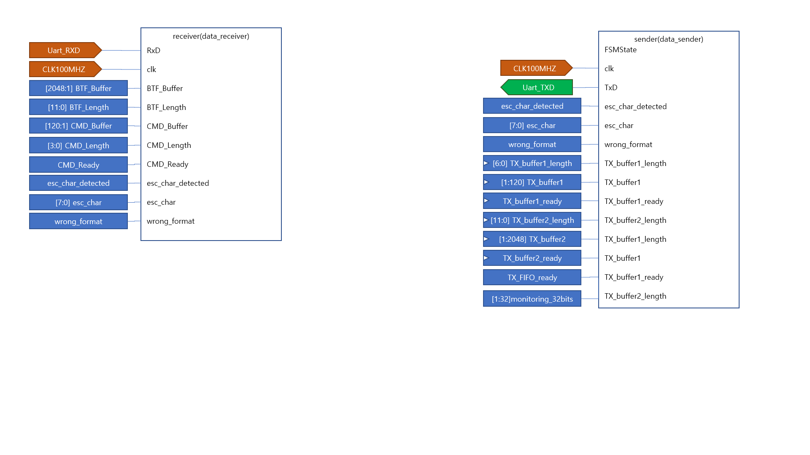

Figure1. receiver, sender module. each module receives signal from PC and sends signal to PC as its name indicates.

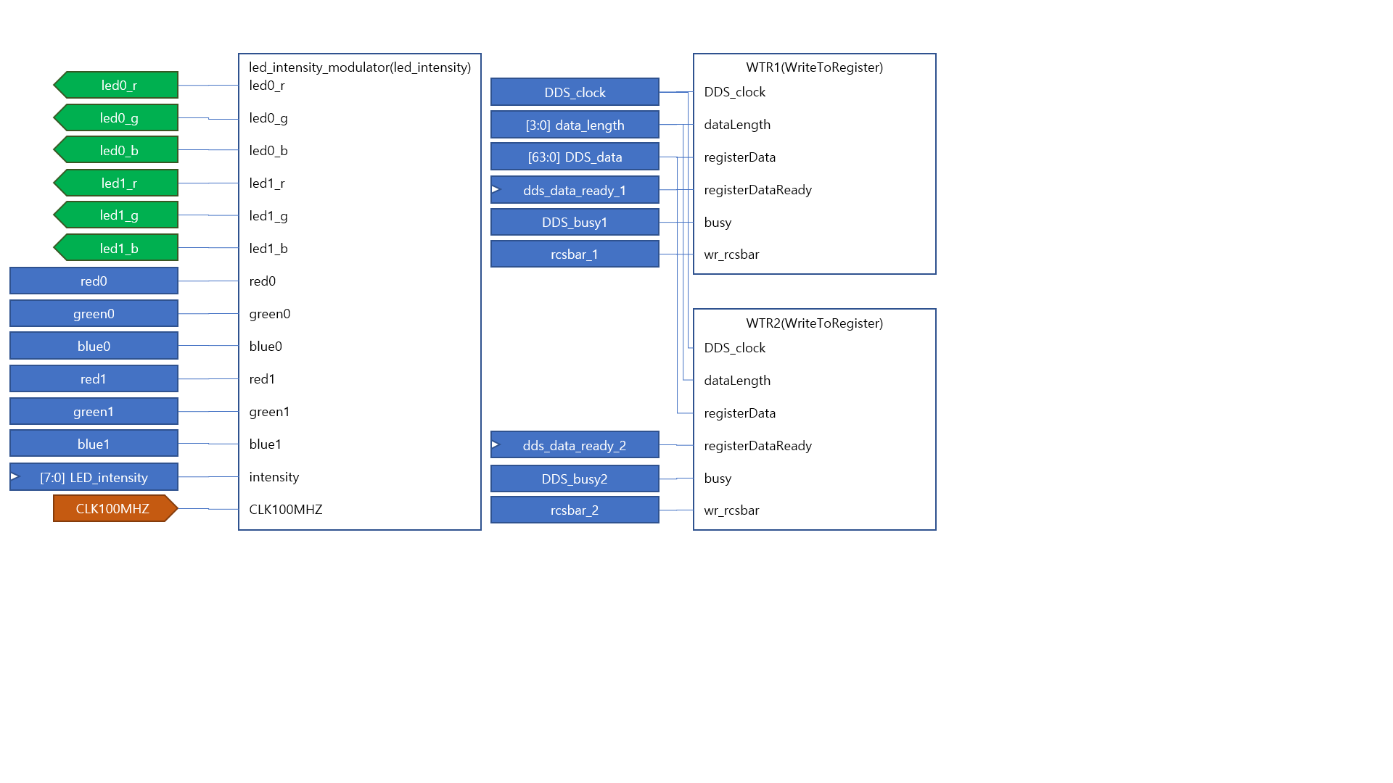

Figure2. led_intensity_modulator, WriteToRegister module. Previous module controls led pins, and latter make SPI signal that control DDS.

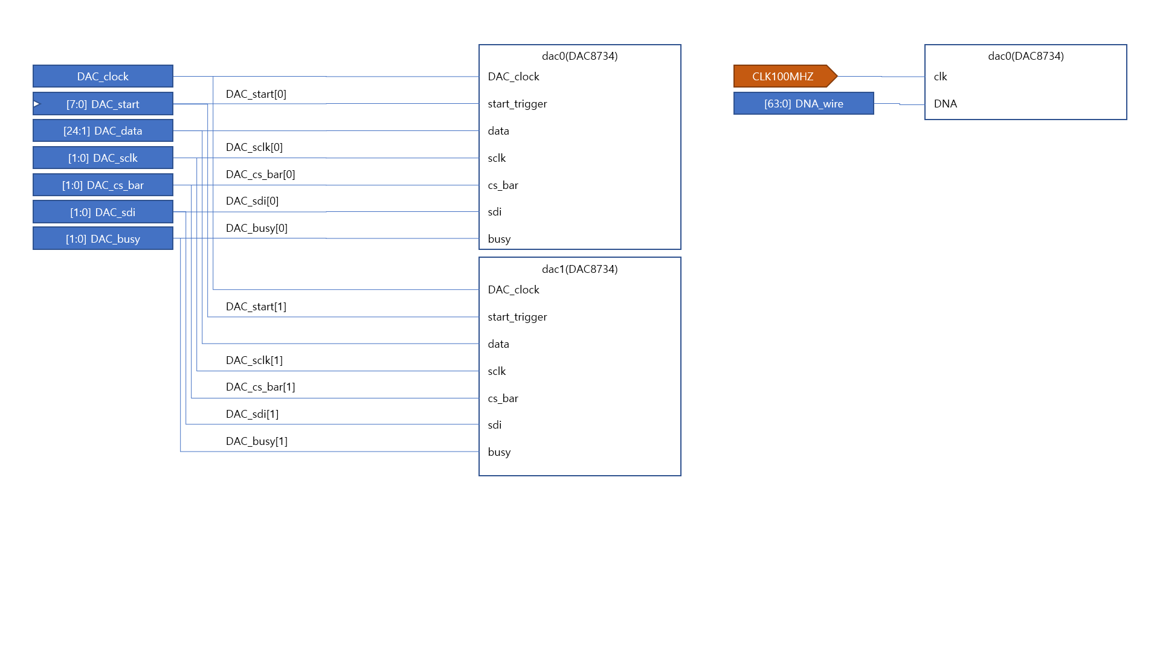

Figure3. DAC8734 modules. These were not modifed in this case.

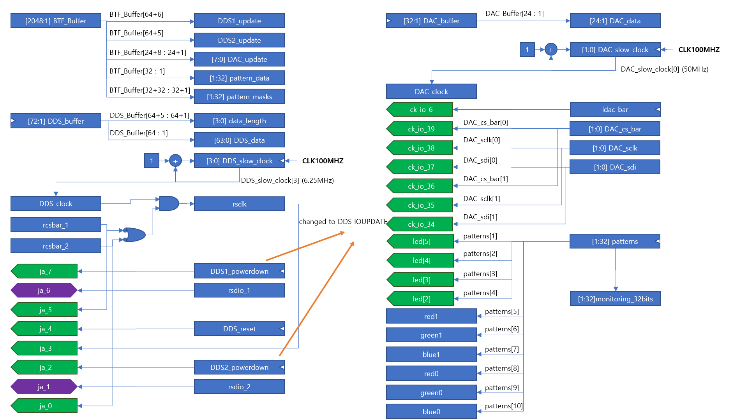

Figure4. SDIO, SCK, CSB pin layout and DAC pin layout. Only DDS pin layout was modified. IO update pin was added to update AD9910 reigster.

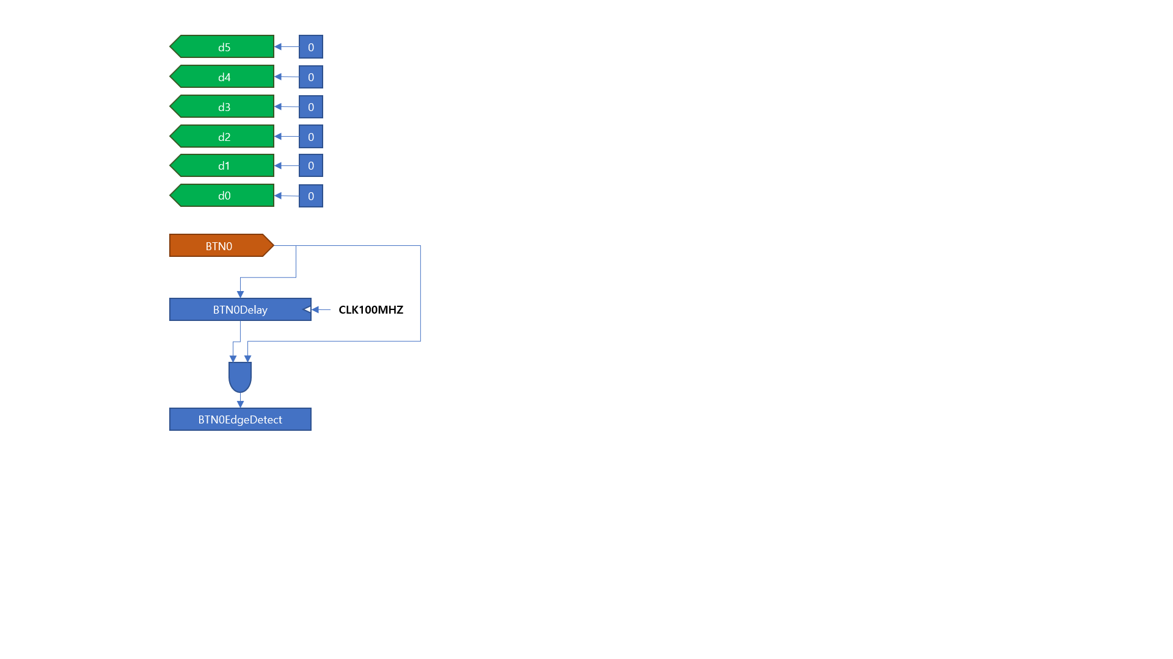

Figure5. Other pins. It seems to be placed for debugging.

First modification in code is that 'DDS1_powerdown', 'DDS2_powerdown' wires in 'AD9912_DAC8734.sv' were replaced to 'DDS1_ioupdate', 'DDS2_ioupdate' pins. These modified pins(ja_7 and ja_0) would make 60ns pulse corresponding to 6 clock cycles. In previous code'DDS1_powerdown', 'DDS2_powerdown' discharged only LOW signal. Second, FSM state 'MAIN_DDS_IOUPDATE_OUT', 'MAIN_DDS_IOUPDATE_END' were added. Addition of IO update signal is made since update of register in AD9912 occurs after IO update pulse. Third, parameter 'DDS_MAX_LENGTH' in same file and 'MAX_LENGTH' in 'WriteToRegister.v' was changed to 9 from 8 due to profile setting which requires 9bytes of signal at once. And some codes were added in 'data_receiver_v1_00.v' to initialize logics in simulation and "\r", "\n" were replaced to ascii code value in 'TERMINATOR_CURRENT_CHAR_POINTER' conditional part since these made error in simulation.

## 1.2.Python Code

Python code 'AD9910_eval.py' controls AD9910 evaluation board through FPGA. Same 'Arty_S7_v1_01' library with AD9912 python code('AD9912_DAC8734_v1_01.py') was imported and serial communication protocol is similar between AD9910 and AD9912. However, AD9910 uses IO_UPDATE pulse as mentioned to update its register meanwhile AD9912 writes to specific register address to update its register(To see more details, refere the AD9910, AD9912 manual). In addition, AD9910 requires fixed length whose maximum including address is 9bytes to update each register, so length of signal is not included in header. On the other hand, AD9912 has mutable length which should be included in header and longest one is 8bytes. Main functions of python code are as below. Notice that these python code and above Verilog modification are old version, and new codes are made. These can be found in section2.

**__init__( fpga, min_freq = 10, max_freq = 400, sys_clk = 1000, unit = 'MHz')**

AD9910 constructor has **fpga**, **min_freq**, **max_freq**, **sys_clk**, unit parameters. **fpga** is ArtyS7 object, **min_freq**, **max_freq** are minimum, maximum output frequency of DDS and **sys_clk** is reference clock for DDS(PLL is not implemented yet). Unit of frequency is set by **unit** parameter and default value is '**MHz**'. '**GHz**', '**kHz**' are also available. Notice that **unit** parameter is removed in after version and use different scheme to indicate unit of parameter. For more detail, see section2.

**make_header_string(register_address, direction = 'W')**

This method makes header string in hexadecimal which is compatible with AD9912's **make_header_string**. In this case, header was made directly in **write16**, **write 32**, **write64** method so this method was not used in other method.

**write16(register_addr, register_data, ch1, ch2)**

This method write 16 bit data to DDS register calling **send_mode_BTF_int_list**, and **send_command** method in **ArtyS7**. **register_addr** is address of register, **register_data** is register data, and **ch1**, **ch2** indicate whether DDS1, DDS2 would be written.

**write32(register_addr, register_data, ch1, ch2)**

This method is similar to **write16**, but write 32 bits to DDS register.

**write64(register_addr, register_data, ch1, ch2)**

This method is similar to **write16**, but write 64 bits to DDS register.

**frequency_to_FTW(freq, unit = 'MHz')**

This method converts frequency to 32 bits FTW which corresponds to ratio of output frequency and system clock frequency. Unit of **frequency** is equal to parameter **unit** and default is '**MHz**'.

**phase_to_POW(phase, unit = 'FRAC')**

This method converts phase to 16 bits POW which corresponds to ratio of output phase offset and two pi. Unit of **phase** is equal to parameter **unit** and default is '**FRAC**'. '**RAD**' and '**DEG**' is also available.

**amplitude_to_ASF(amplitude_frac)**

This method converts fraction between output amplitude and maximum amplitude to 14 bits ASF. There is no **unit** parameter and only support fraction.

**set_frequency(freq, ch1, ch2, unit = 'MHz')**

This method sets value in FTW register. Unit of frequency is equal to parameter **unit** whose default value is '**MHz**', and **ch1**, **ch2** indicate whether DDS1, DDS2 will be written. Note that this method does not change single tone profile register. This register will be used in RAM mode, DRG mode, parallel mode.

**set_phase(phase, ch1, ch2, unit = 'FRAC')**

This method sets value in POW register. Unit of phase is equal to parameter **unit** whose default value is '**FRAC**', and **ch1**, **ch2** indicate whether DDS1, DDS2 will be written. Note that this method does not change single tone profile register. This register will be used in RAM mode, DRG mode, parallel mode.

**set_amplitude(amplitude_frac, ch1, ch2)**

This method sets value in ASF register. **ch1**, **ch2** indicate whether DDS1, DDS2 will be written. Note that this method does not change single tone profile register. This register will be used in RAM mode, DRG mode, parallel mode.

**initialize()**

This method initializes CFR register of DDS to singletone mode using **set_CFR1(...)**, **set_CFR2(...)**, **set_CFR3(...)** methods.

**set_CFR1( ch1, ch2, ram_en = 0, ram_playback = 0, manual_OSK = 0,**

**inverse_sinc_filter = 0, internal_porfile = 0, sine = 1,**

**load_LRR = 0, autoclear_DRG = 0, autoclear_phase = 0,**

**clear_DRG = 0, clear_phase = 0, load_ARR = 0, OSK_en = 0,**

**auto_OSK = 0, digital_power_down = 0, DAC_power_down = 0,**

**REFCLK_powerdown = 0, aux_DAC_powerdown = 0,**

**external_power_down_ctrl = 0, SDIO_in_only = 0,**

**LSB_first = 0)**

**set_CFR2( ch1, ch2, amp_en_single_tone = 1, internal_IO_update = 0,**

**SYNC_CLK_en = 0, DRG_dest = 0, DRG_en = 0,**

**DRG_no_dwell_high = 0, DRG_no_dwell_low = 0, read_eff_FTW = 1,**

**IO_update_rate = 0, PDCLK_en = 0, PDCLK_inv = 0, Tx_inv = 0,**

**matched_latency_en = 0, data_ass_hold = 0, sync_val_dis = 1,**

**parallel_port = 0, FM_gain = 0)**

**set_CFR3( ch1, ch2, DRV0 = 0, PLL_VCO = 0, I_CP = 0,**

**REFCLK_div_bypass = 1, REFCLK_input_div_reset = 1,**

**PFD_reset = 0, PLL_en = 0, N = 0)**

These methods set CFR register of DDS as its name indicate. It has parameters which compose each CFR register and could be set manually. Each role of parameter can be found in AD9910 manual.

**set_profile(freq, phase, amplitude, ch1, ch2, profile = 0, unit_freq = 'MHz', unit_phase = 'FRAC')**

This method sets frequency, phase, and amplitude of DDS profile register. Unit of frequency and phase equal to **unit_freq**, and **unit_phase** each.

## 1.3.Implementation

### 1.3.1. Debugging Output of FPGA board

Bit stream file was uploaded to ArtyS7 board, and output of FPGA was checked by MSO7054 oscilloscope. ja7, ja6, ja5, ja3, and GND pin of ArtyS7 was connected to RIGOL cable. The other end of this cable was connected to oscilloscope LA port. To measure output signal of FPGA using oscilloscope, turn on LA port. And there would be output signal of FPGA on oscilloscope screen as green lines. Then, set oscilloscope as a decode mode and convert it to SPI mode. After that, match each source of CSB, MOSI, MISO, SCK with proper cable number. And then, set horizontal time interval adequately. In this case, 1~5us would be sufficient to see output signal. Finally push SINGLE button on oscilloscope and make output of FPGA using python program(AD9910.py) on the computer. Then, there would be output signal of FPGA on the oscilloscope screen. Procedure is as follows.

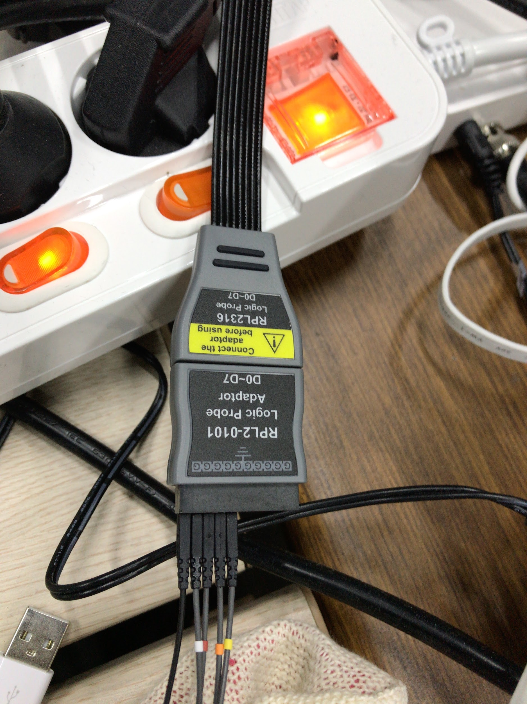

Figure6. Connection between FPGA and oscilloscope linked by RIGOL cable.

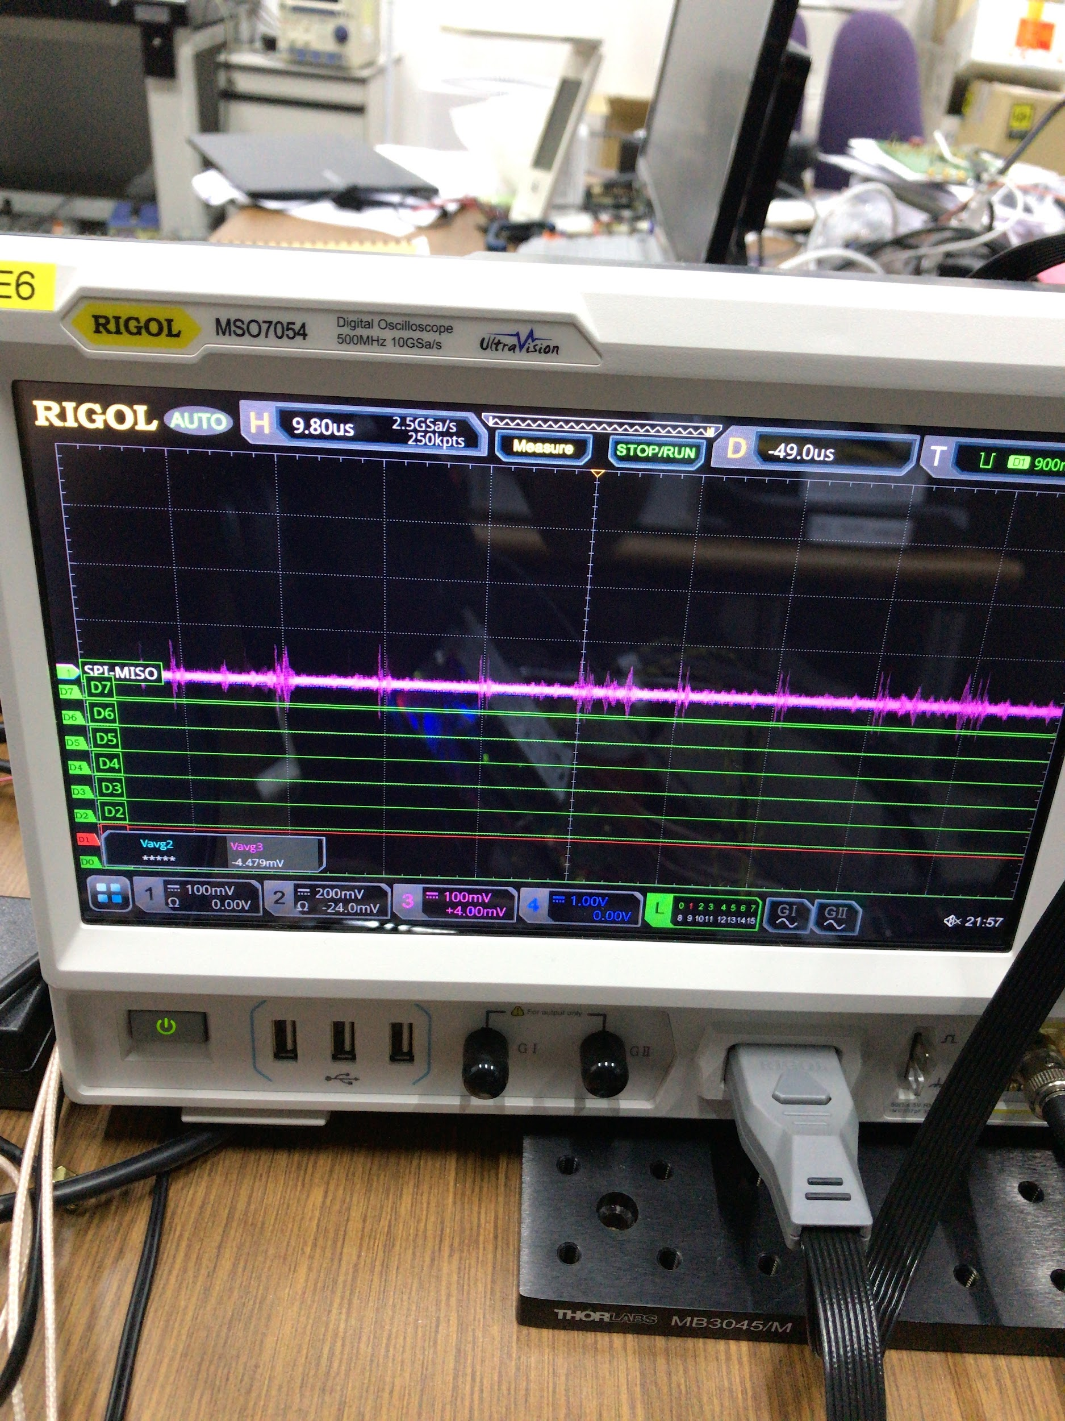

Figure7. Oscilloscope screen after LA button is set. Green line appears when LA button is pushed.

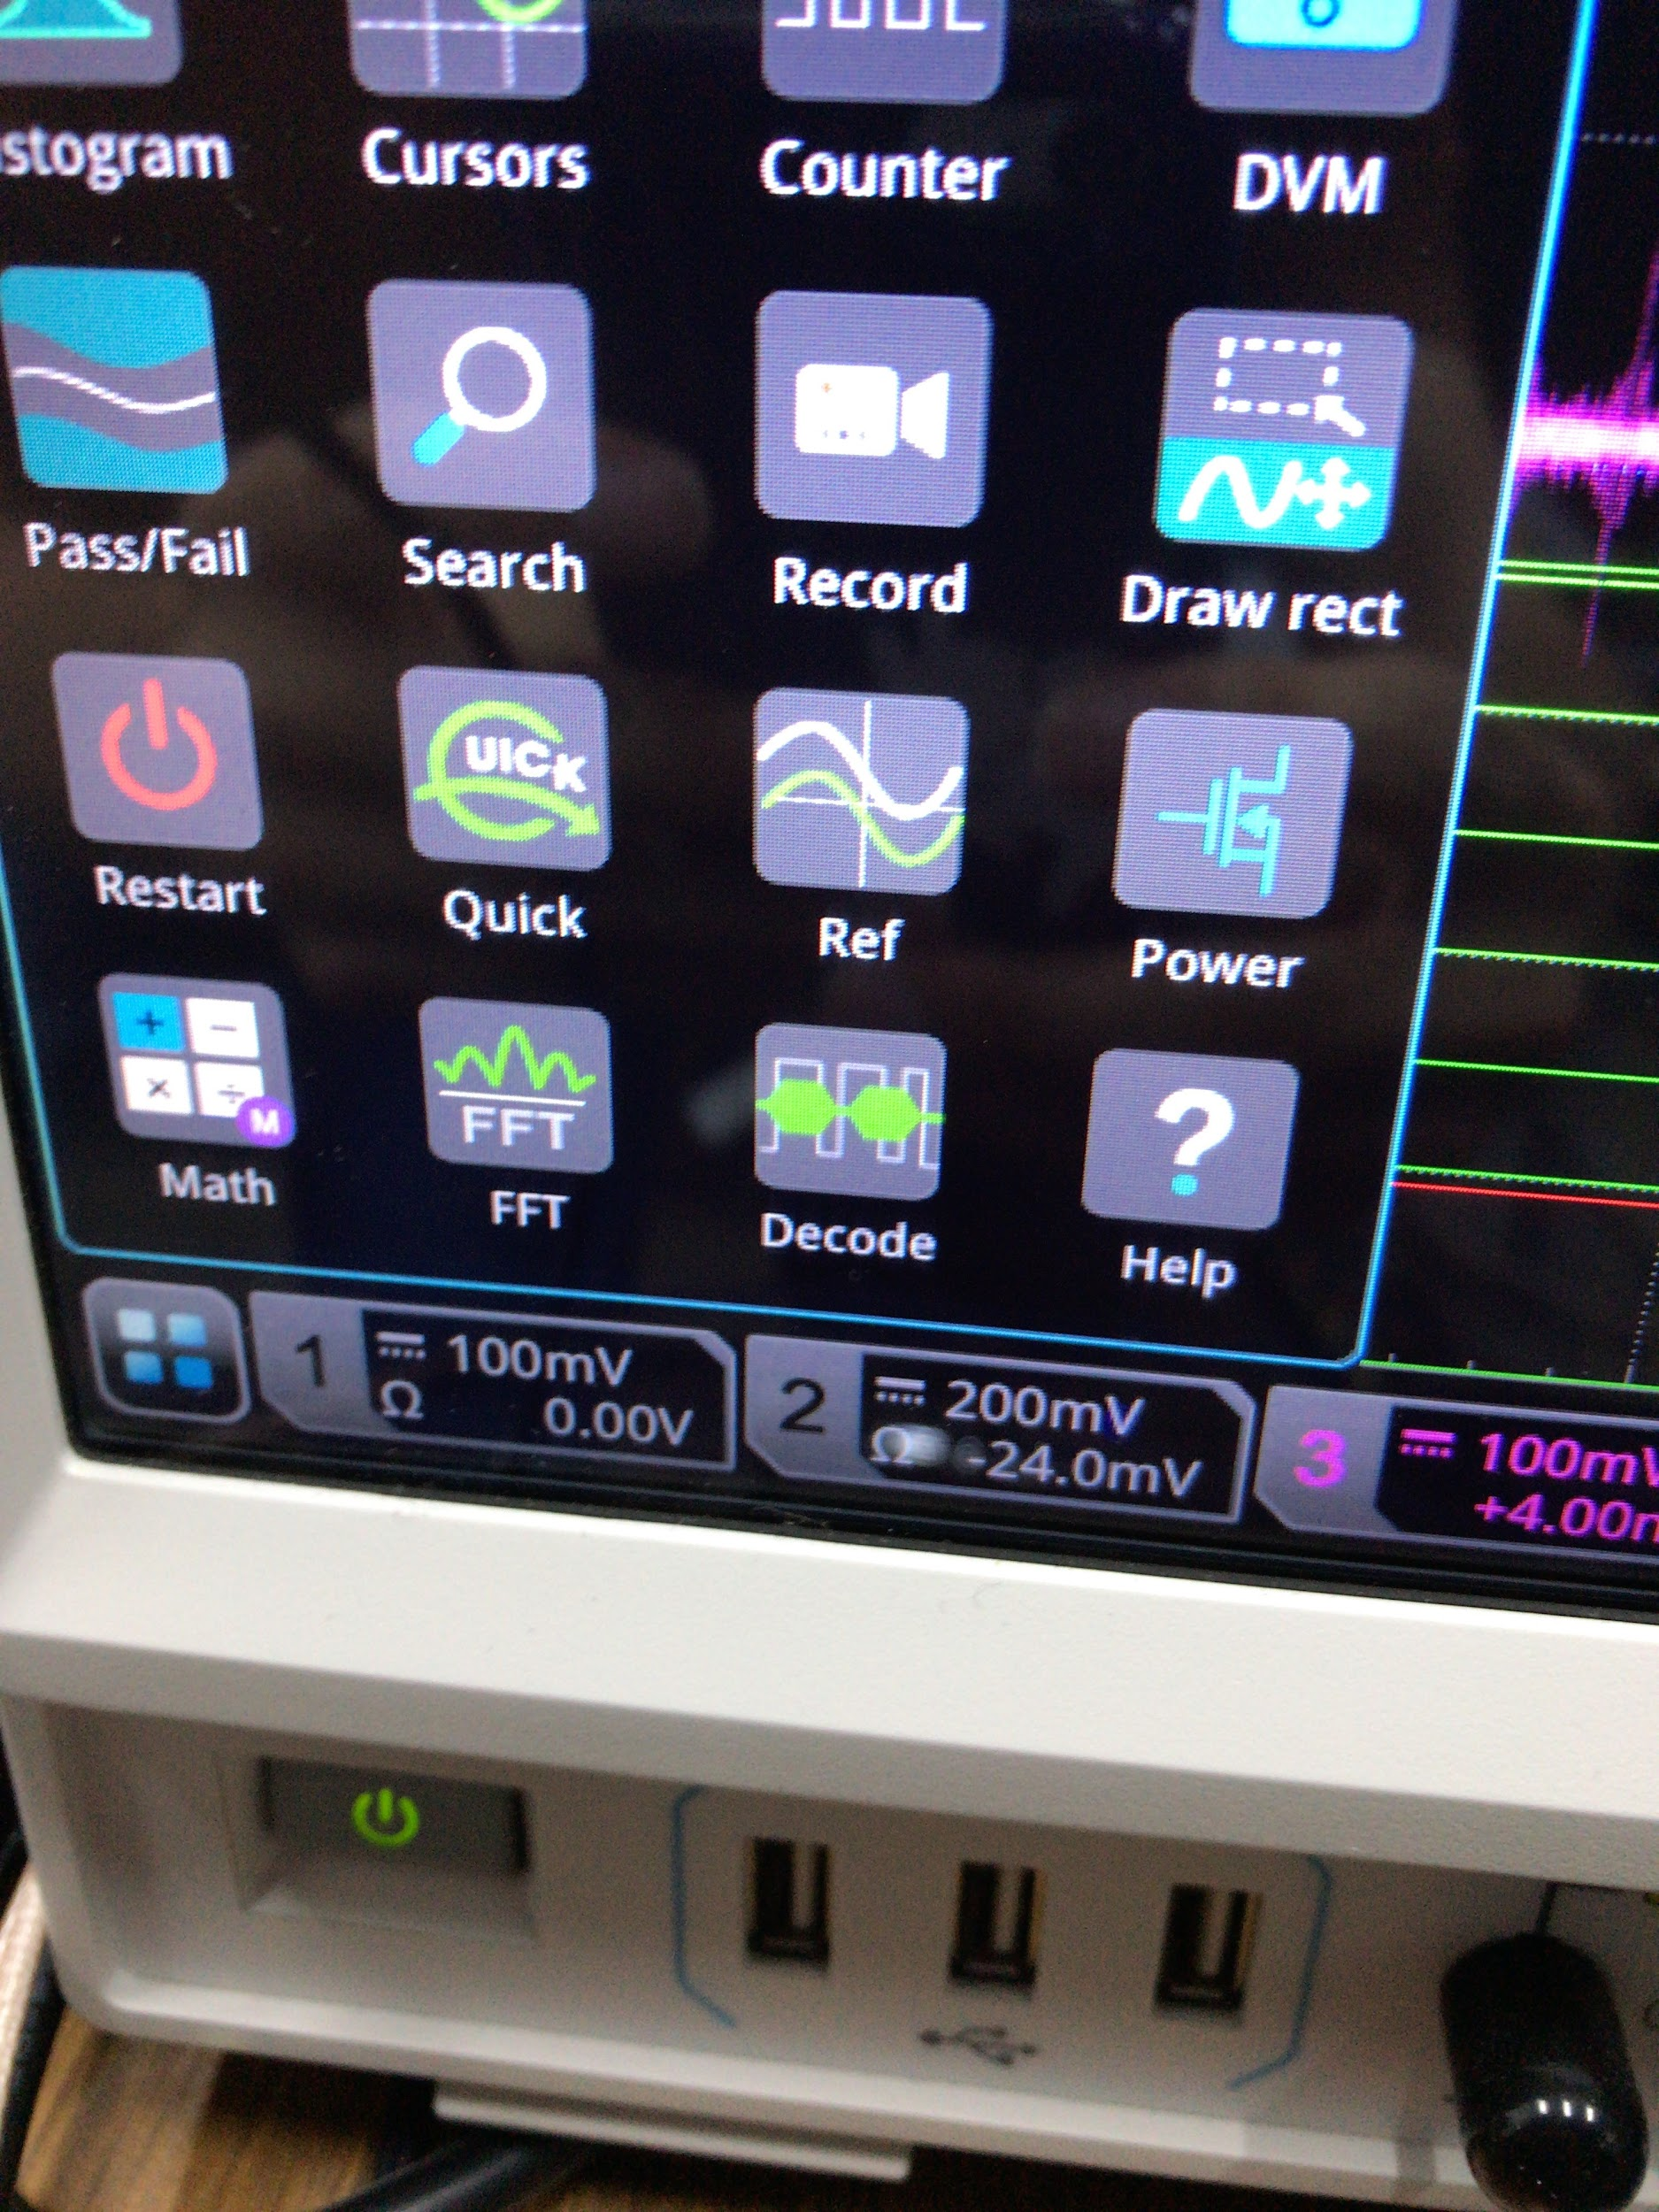

Figure8. Decode mode setting. Decode button will be appear if left below box is selected.

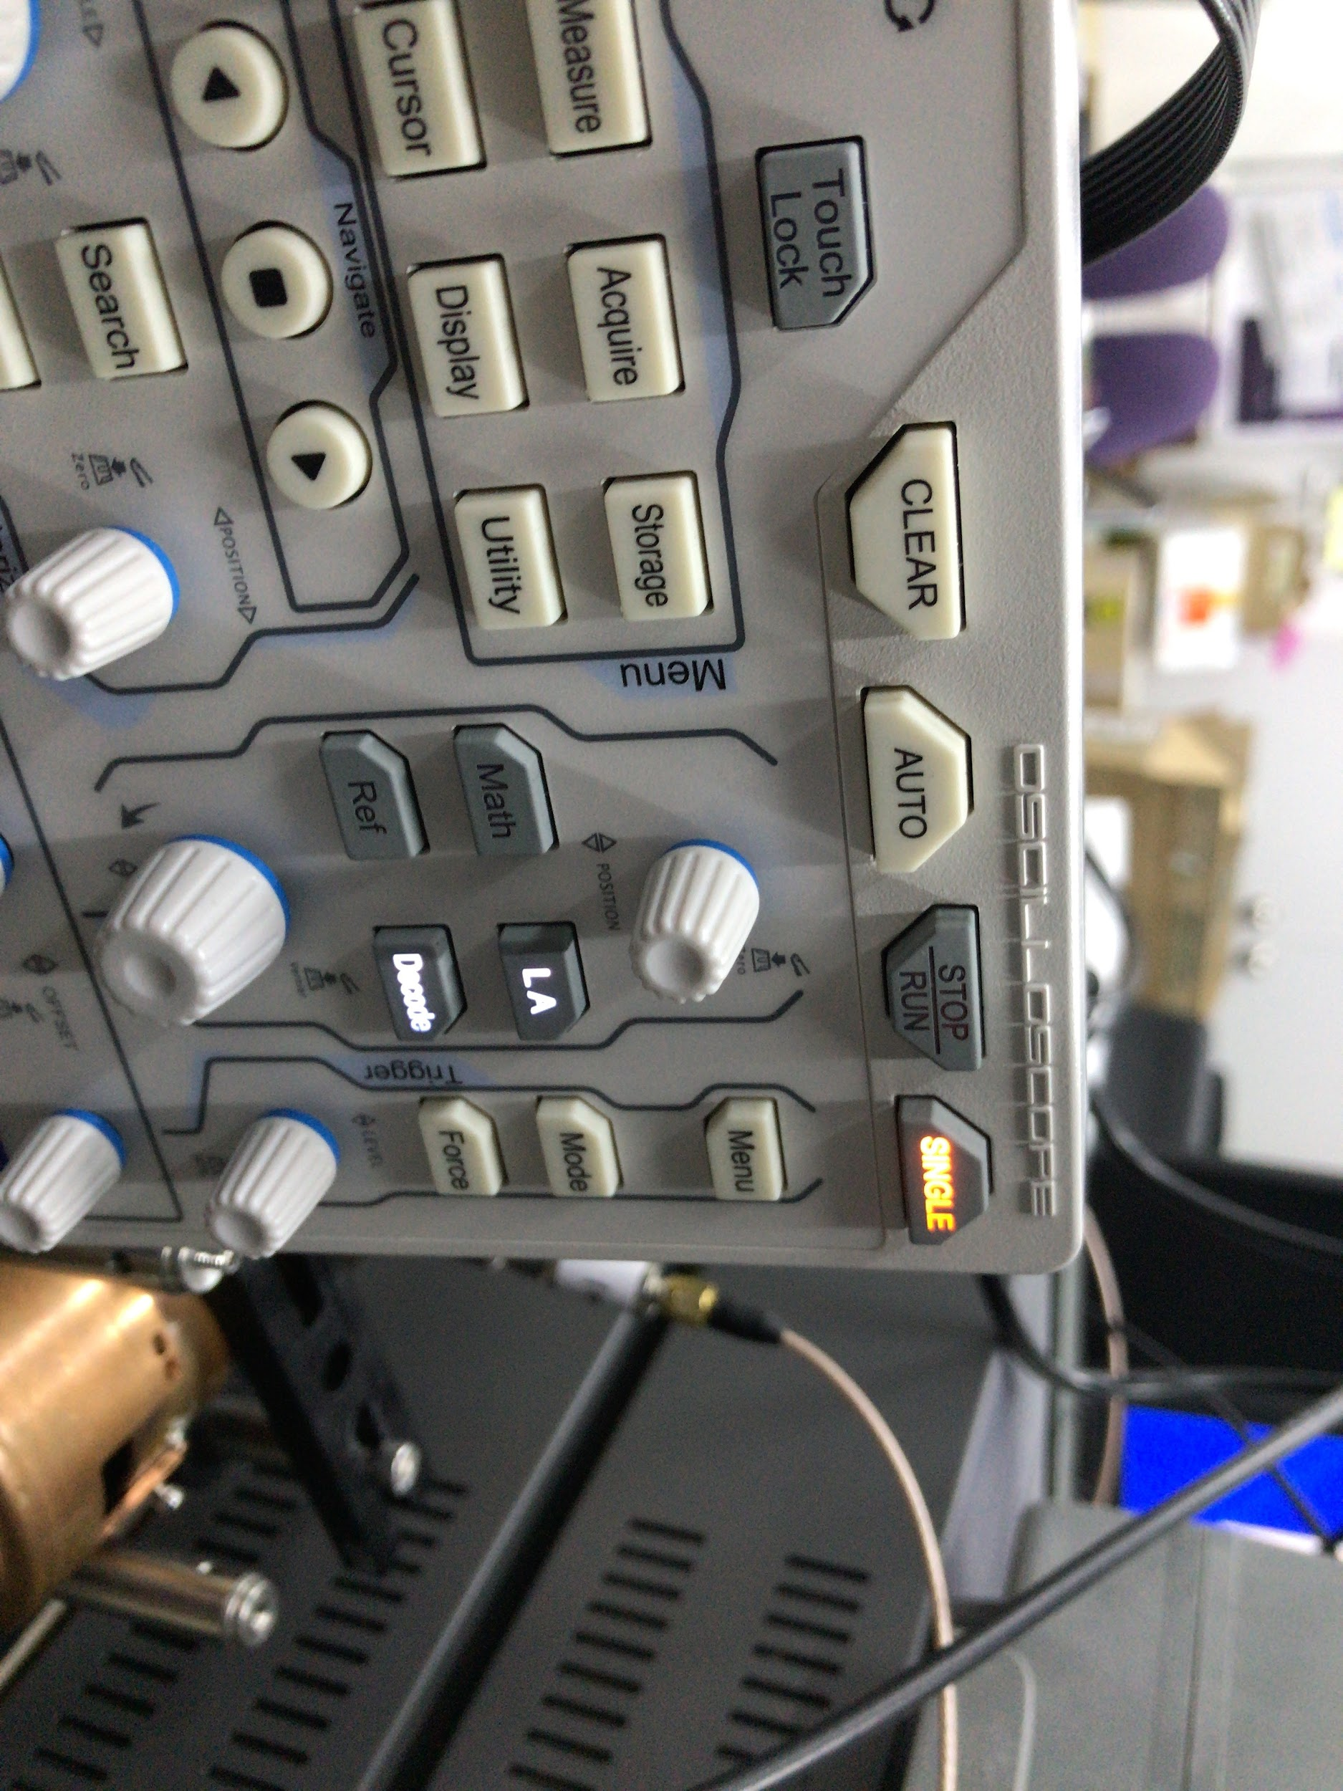

Figure9. Position of SINGLE button. Push SINGLE button before making output from FPGA, there would be no signal on screen before DDS output.

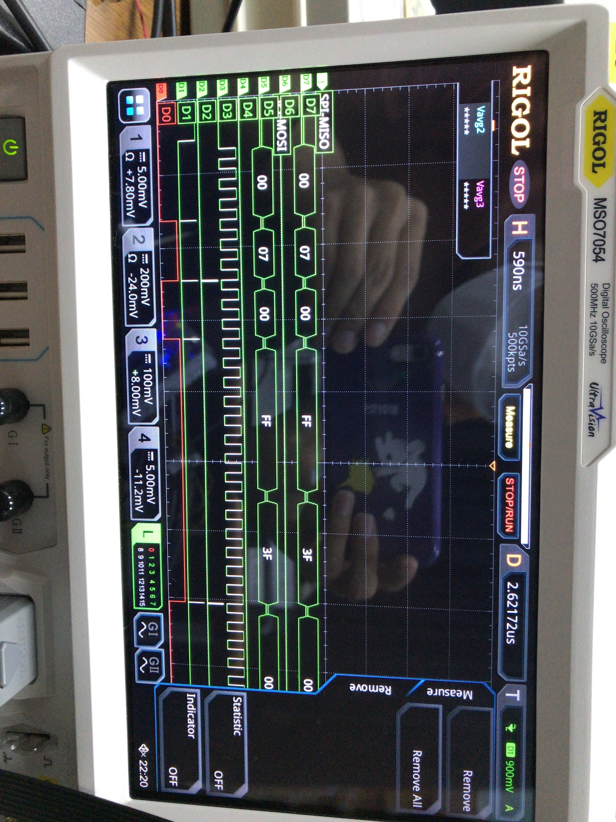

Figure10. Oscilloscope screen after FPGA output is discharged. FPGA output appears on oscilloscope screen

### 1.3.2. Measurement of DDS Output

#### 1.3.2.1. Using Analog Program

Running DDS board requires signal generator(SG384), DC supply(2230G-30-6). And control of DDS needs connection of computer between board using USB cable, and proper jumper setting on the board. Also measuring waveform of DDS needs oscilloscope(TDS3032B). First, set signal generator frequency to 500MHz, and output power bigger than 10.0dBm. Maximum input reference clock of AD9910 is 1GHz, but using Analog program limits it to 500MHz, so in this case reference clock should be less than 500MHz. Then, connect output of signal generator to DDS board using SMA to SMA cable. After that, set DC supply to 1.8V, and 3.3V for two port. Then connect each output and ground port of DC supply with evaluation board properly. Voltage requirement and ground is written on evaluation board. Connecting each port separately, or using ferrite bead among different voltage ports is demanded for more precise waveform. However, purpose of this test is just checking functionality of DDS so it was not considered. Then set jumper W1, W2, W4 on the evaluation board to enable, and place jumper W5, W6, W3( in other words, make connection of two pins located at that jumper port). And set W7 to REF_CLK(since signal generator is used for reference clock in this case) and W11 pin to middle(since TxE pin was not used in this case. This would be used in parallel mode). And connect DDS board to PC, then you can see VBUS led being flashed in red, and USB led being blinking in yellow. If not, connection and instrument setting should be checked again. Then turn on AD9910 program on the computer. If program is not installed, this can be found in Google easily. After program is turned on, there would be two green bar left below of program. In this case, external clock should be set to 500MHz since input of reference is equal to 500MHz. Then connect FILTERED_IOUT to oscilloscope using SMA to BNC cable. To see simple waveform, set profile0 output frequency 200MHz, phase offset 0 DEG and push LOAD button on the Analog program. Notice that Enable Multiplier, Power Down should be disabled. In addition, if IO UPDATE option is not set to Auto, IO UPDATE signal should be sent manually to update register of DDS.

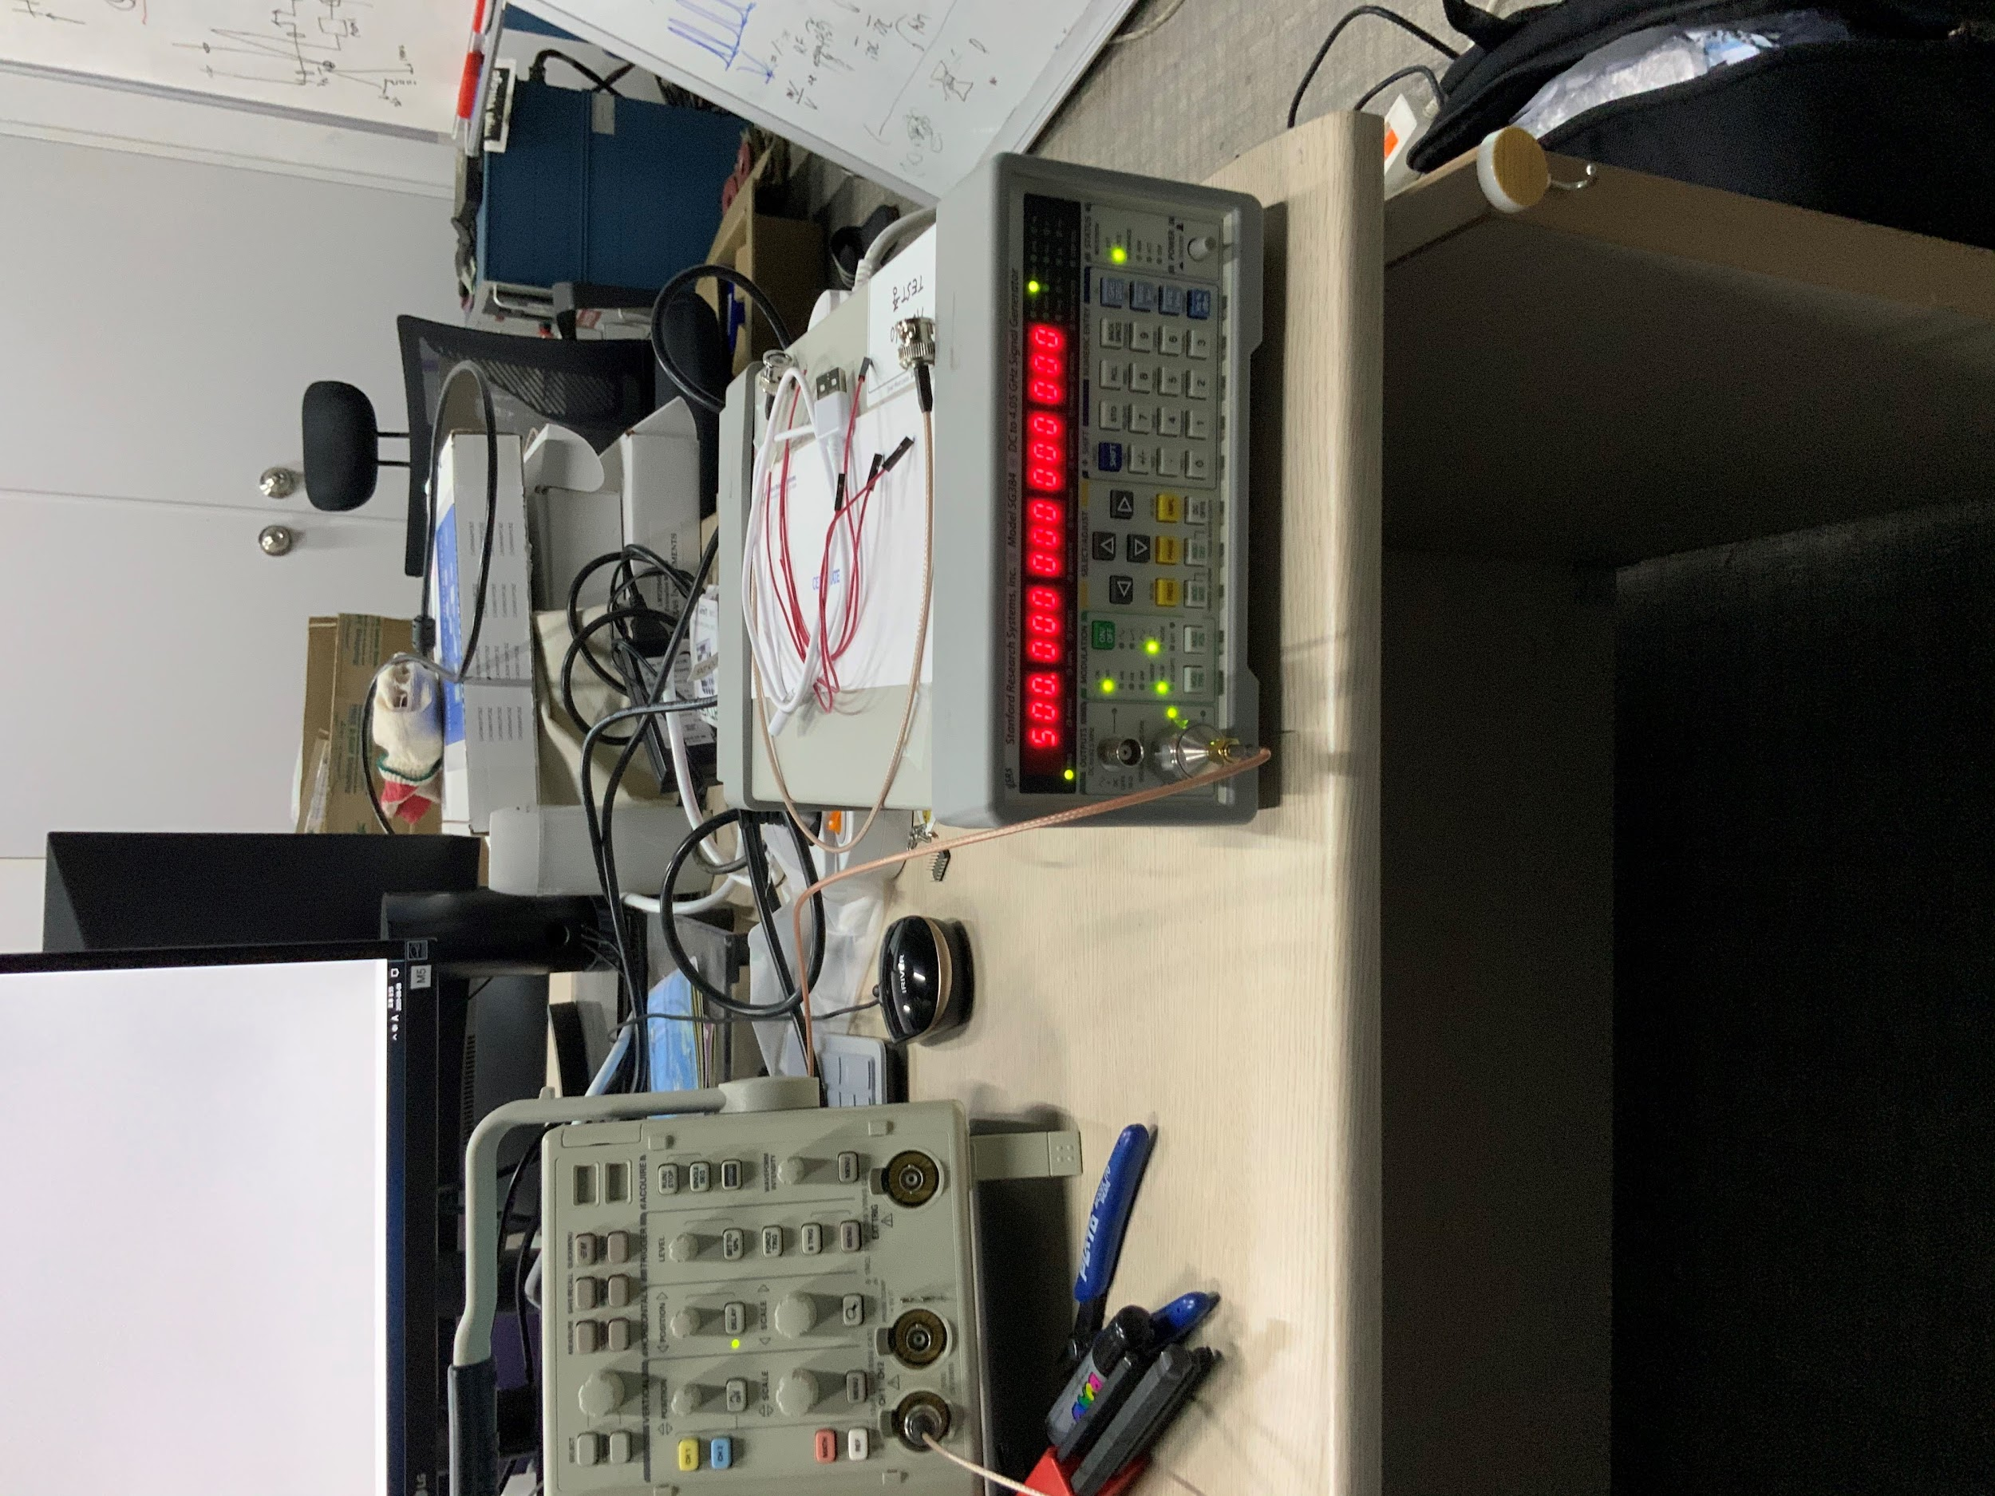

Figure11. Signal generator setting. Proper signal generator output should be selected. In this case, SMA output is appropriate due to high output frequency.

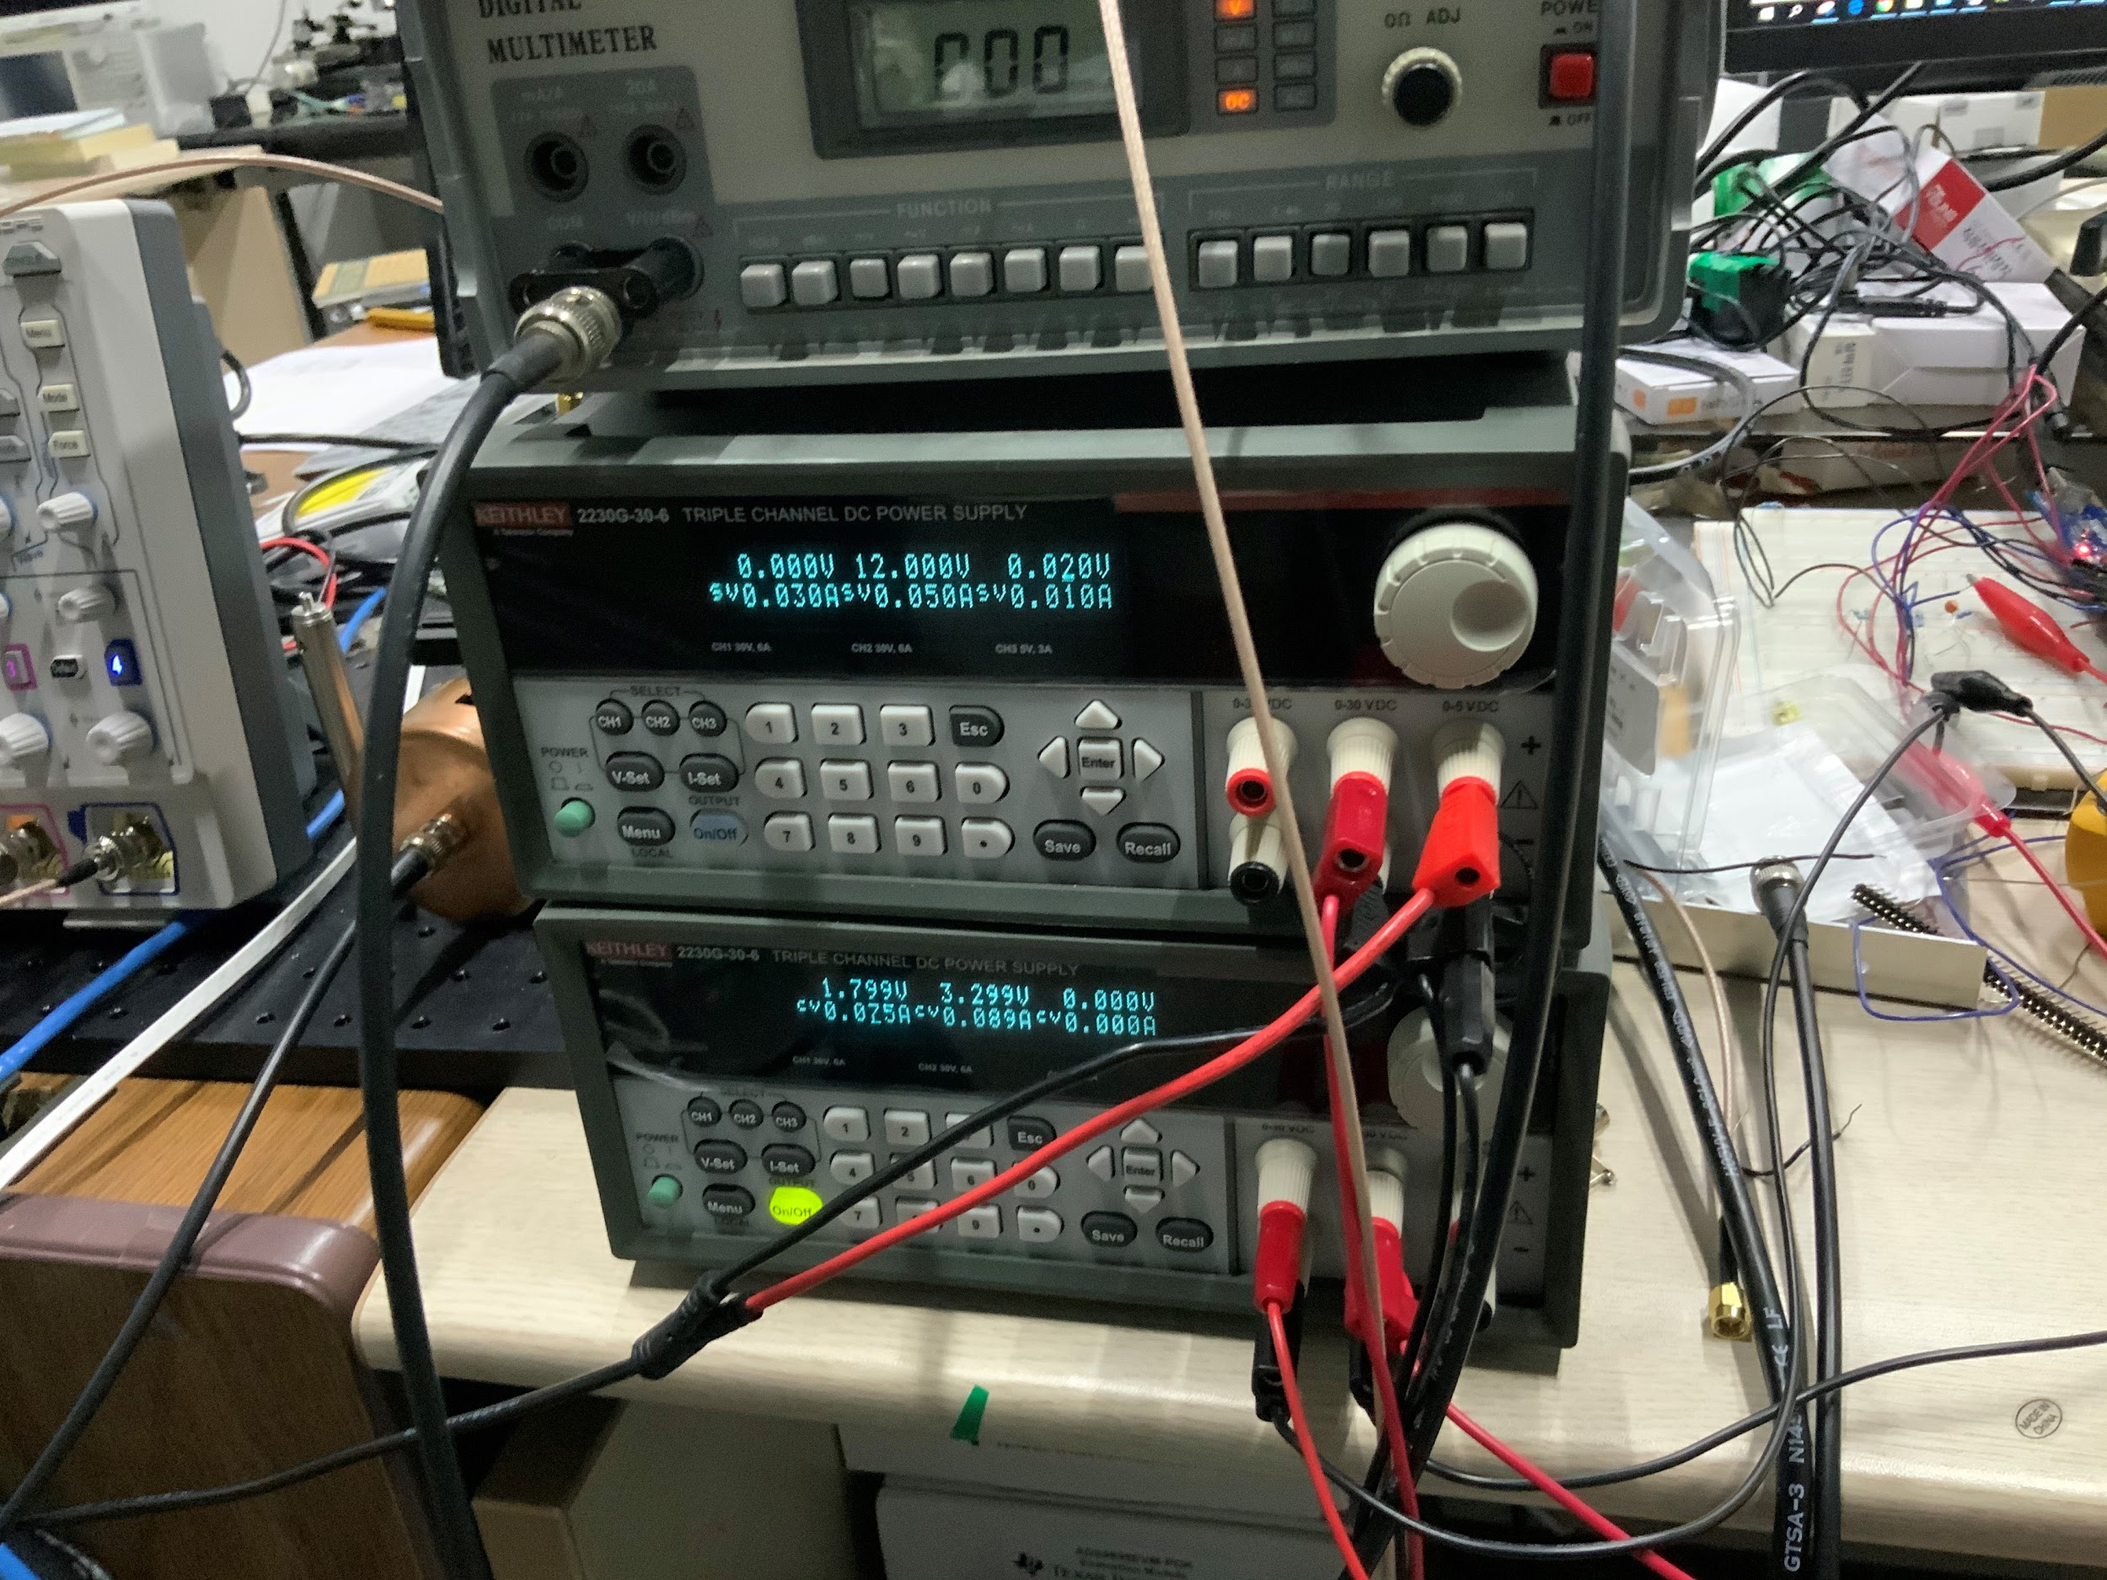

Figure12. DC supply setting. If CC occurs, set proper current to DC supply. 100mA ~ 200mA will work well.

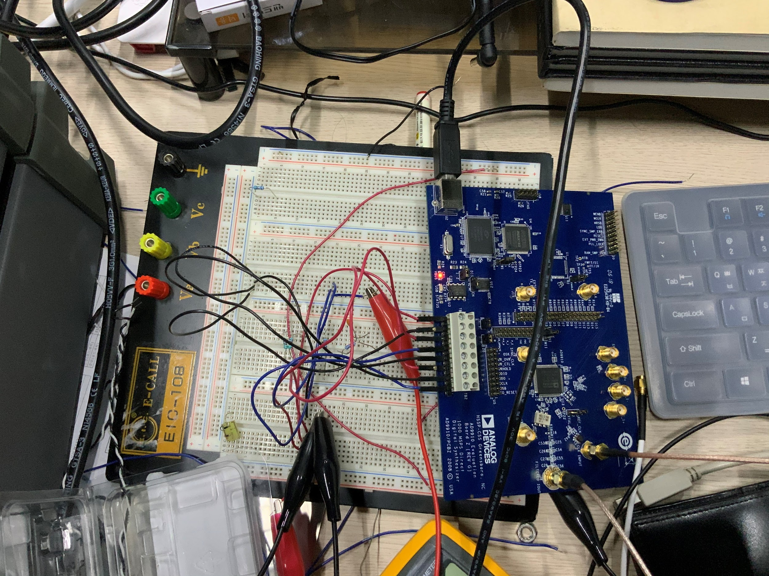

Figure13. Evaluation board and DC voltage connection. If DC voltage supply and jumper setting are adequate, red flash at VBUS and green blanking at USB will appear.

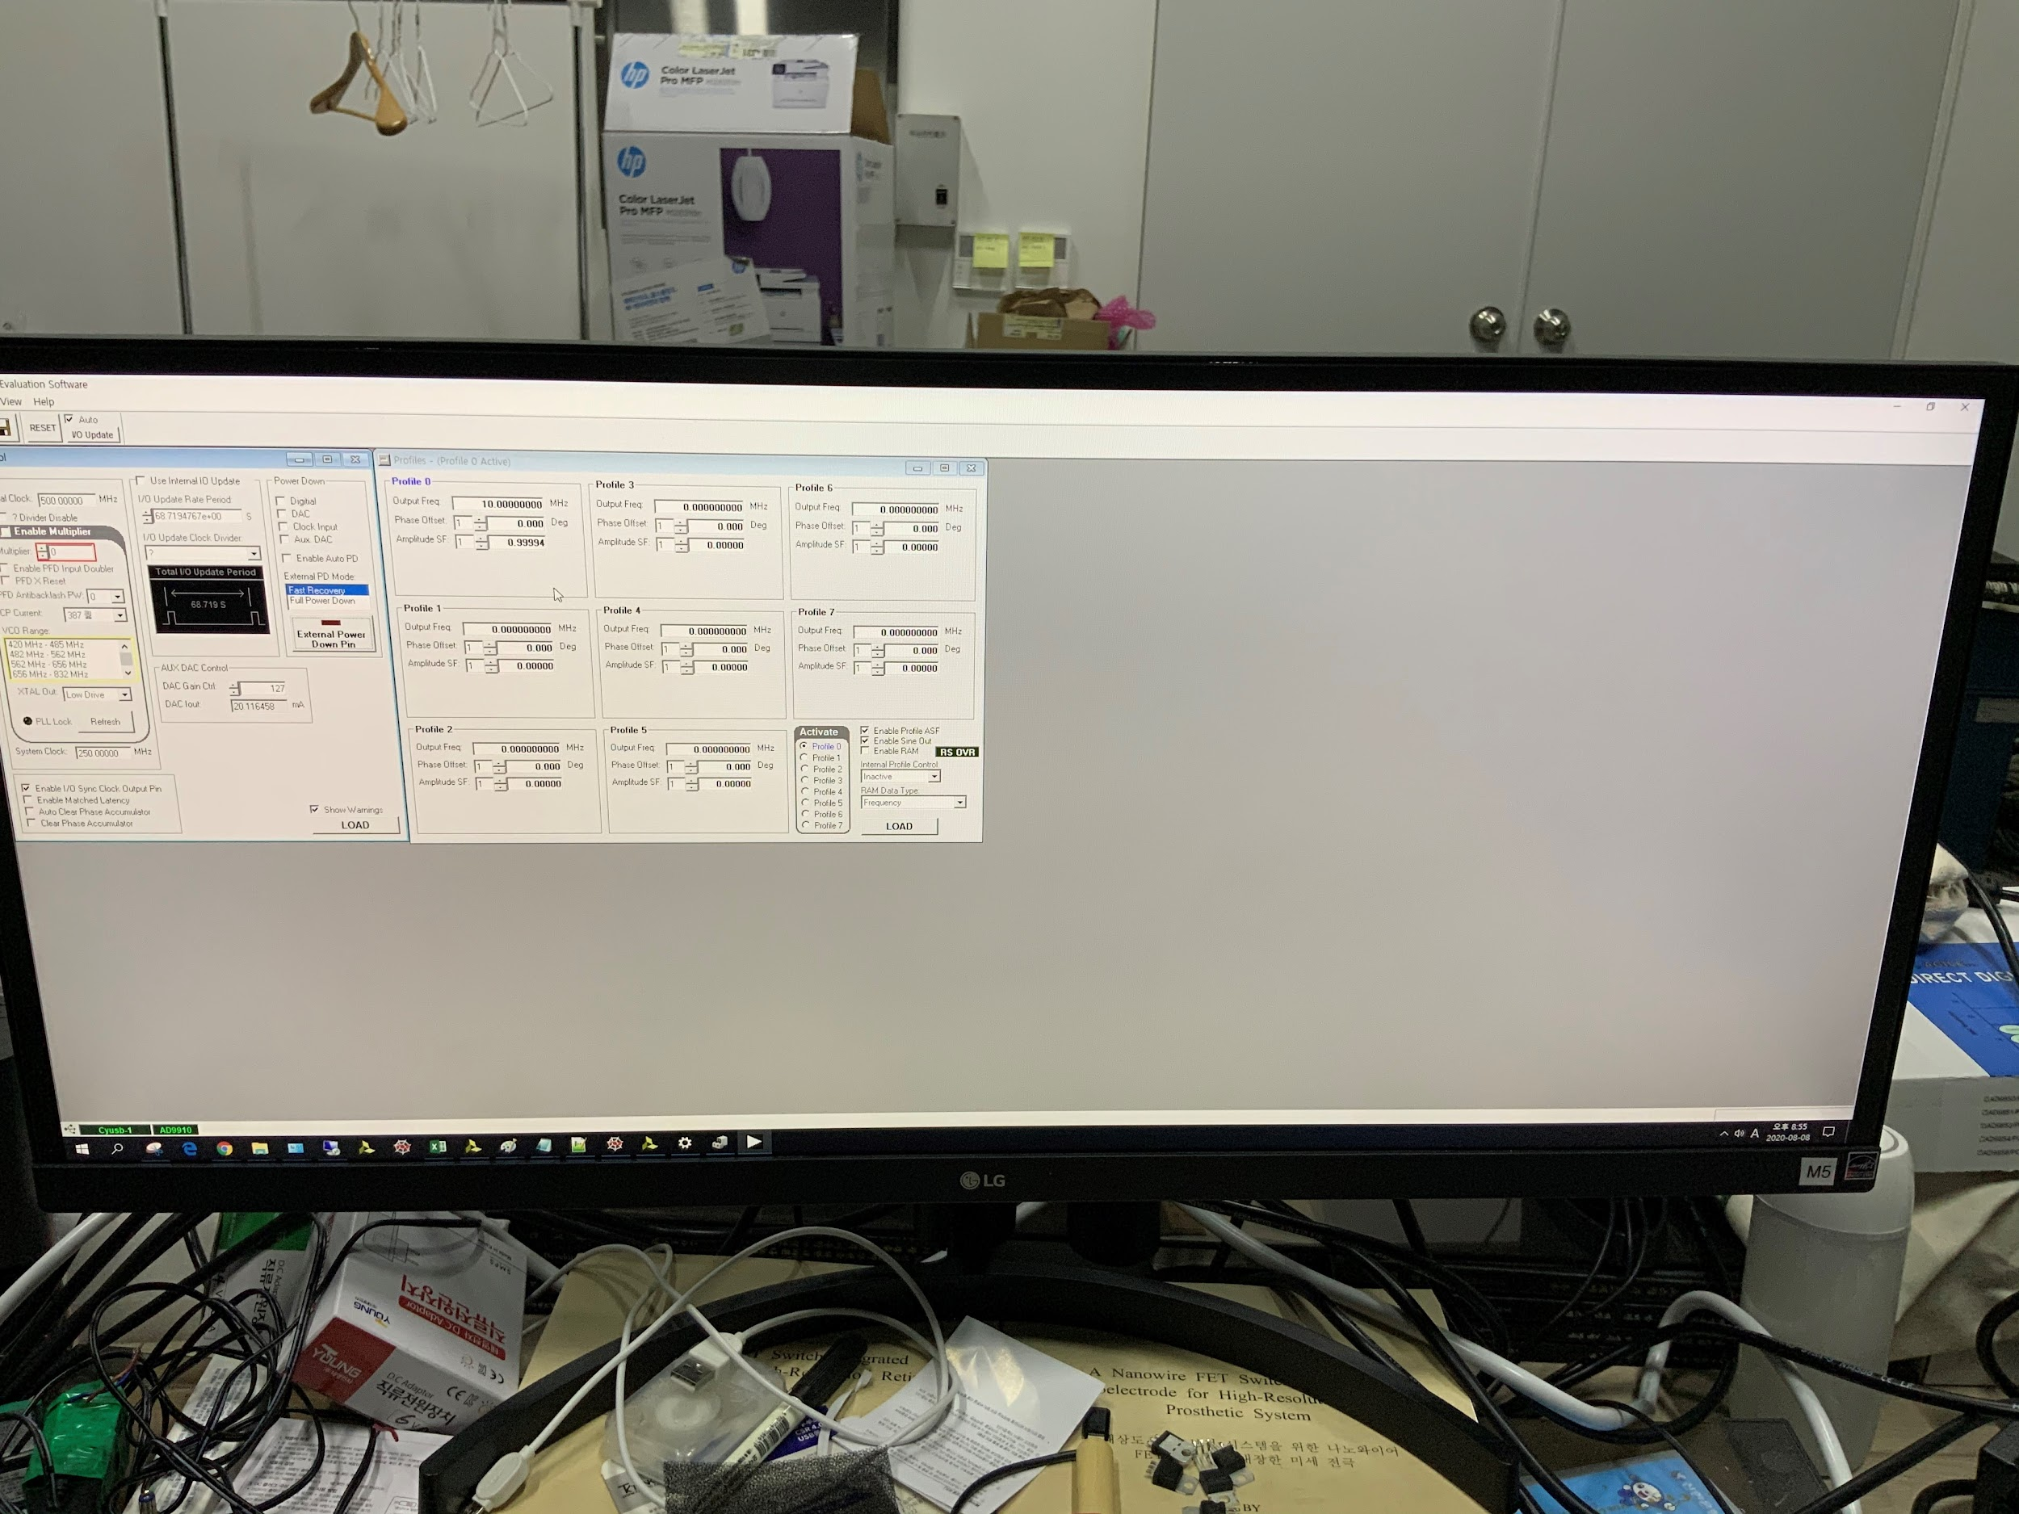

Figure14. Analog program. There would be two green bar at the left below of screen if setting is well done.

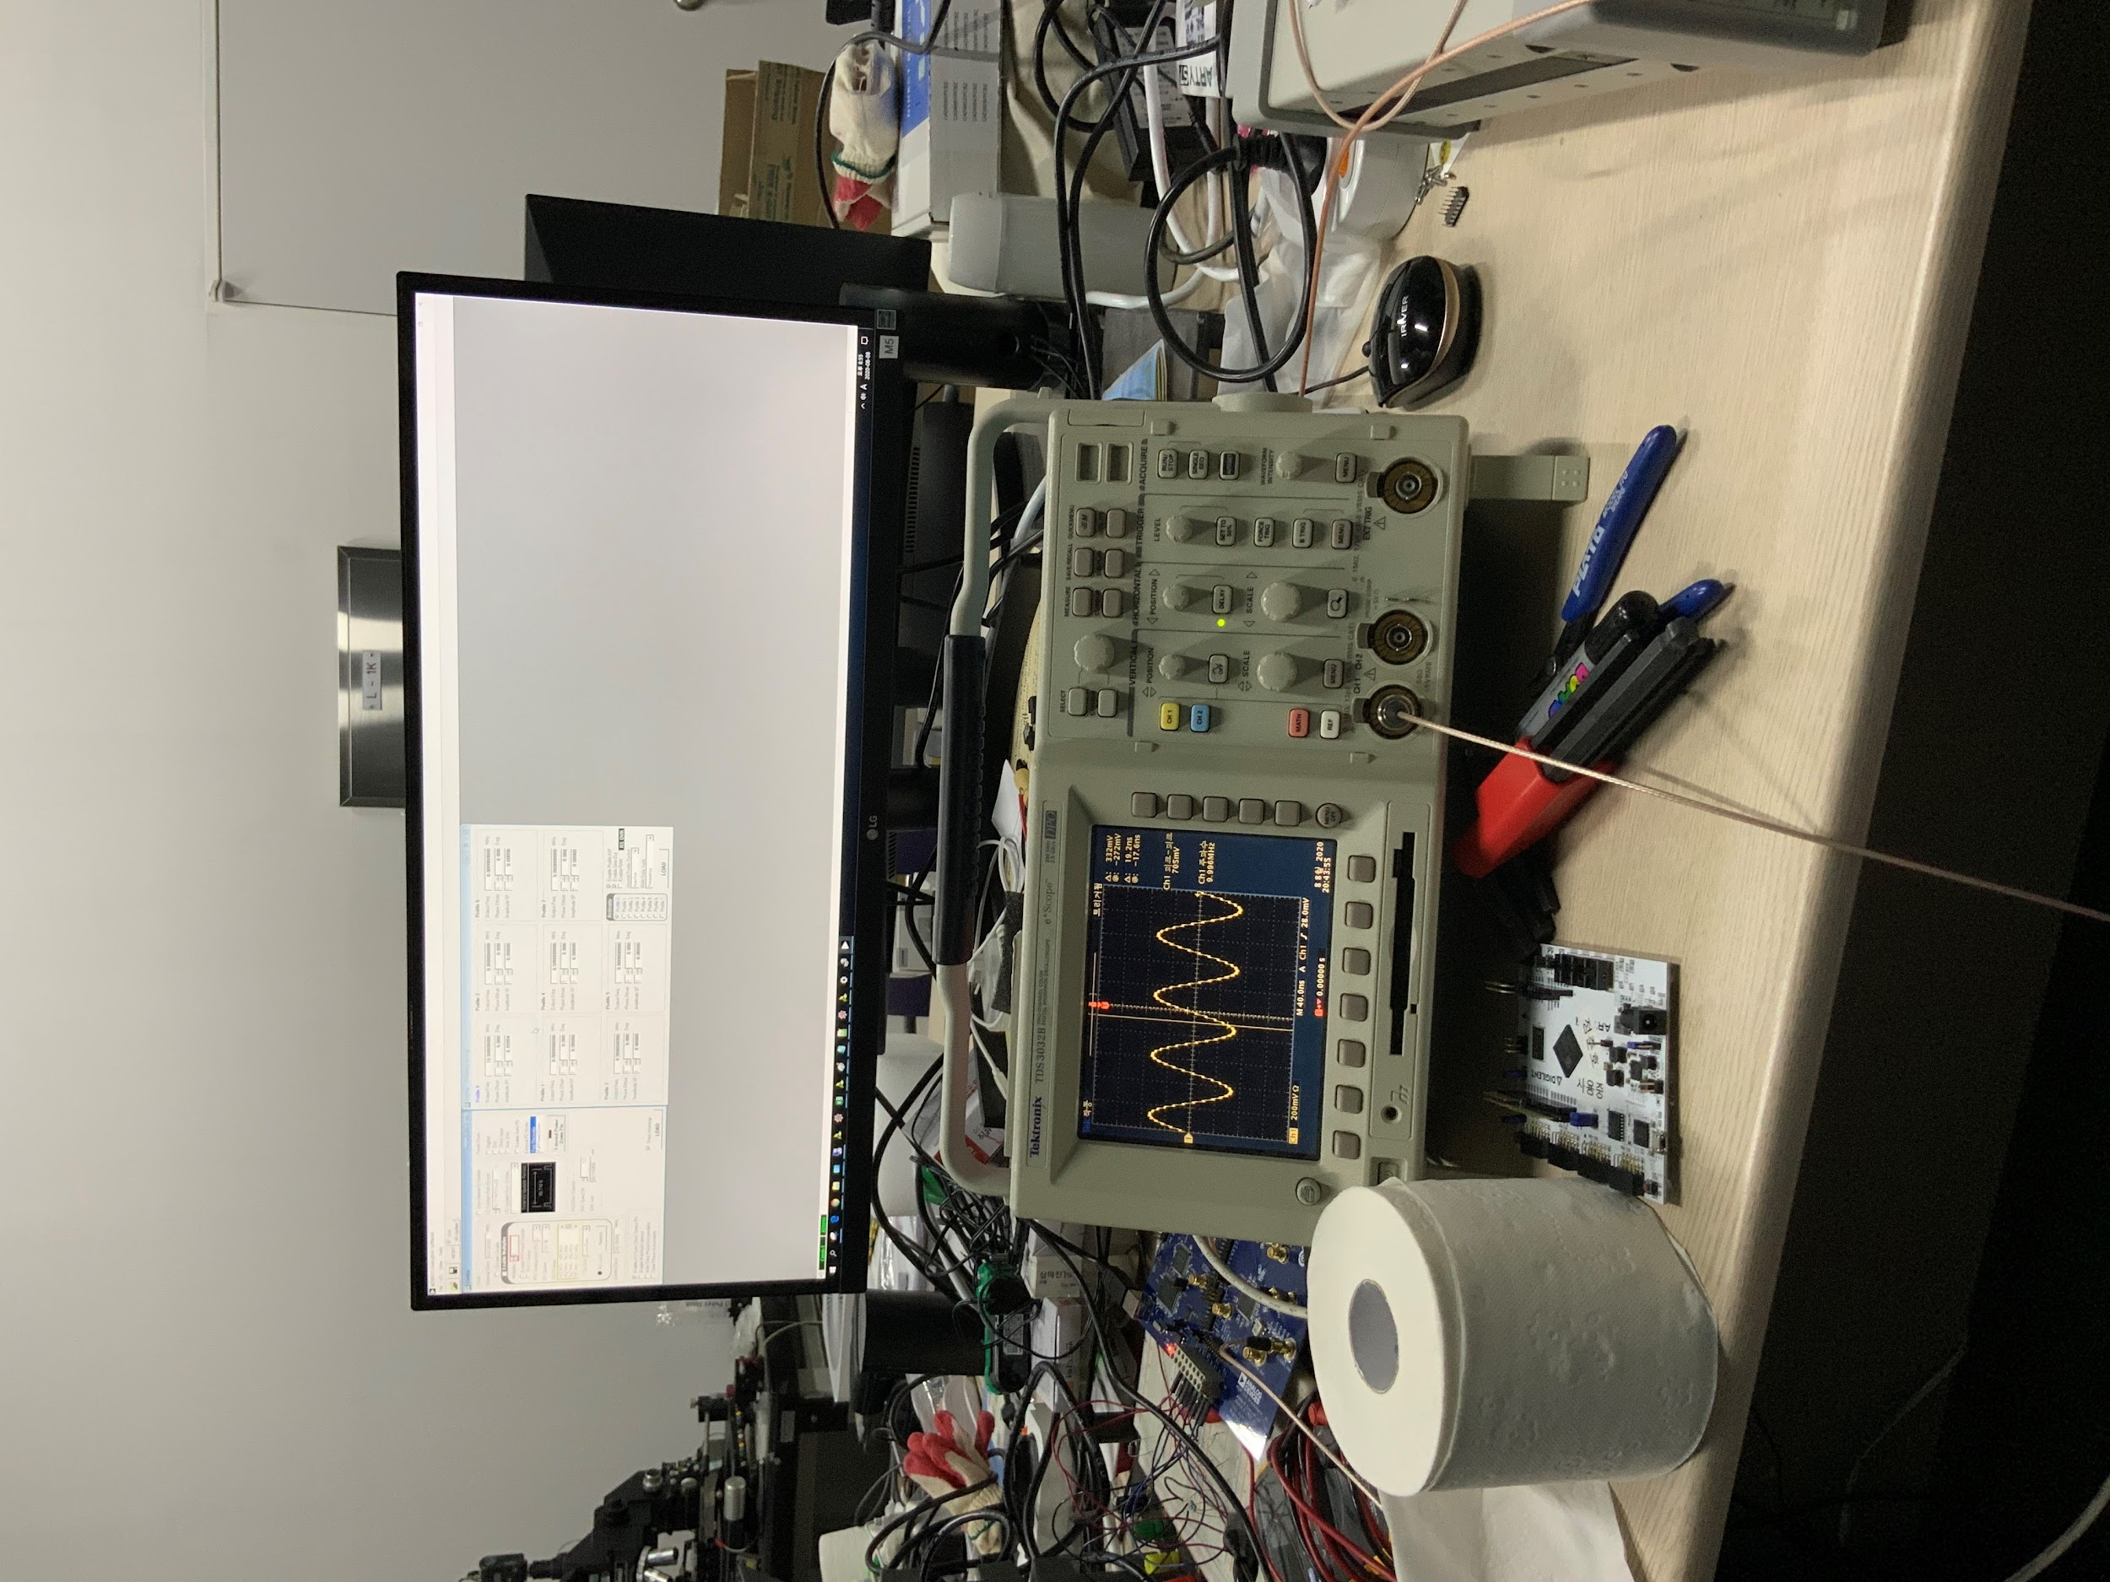

Figure15. Output measurement and oscilloscope setting. Oscilloscope has internal 50 Ohm register, so direct connection between DDS and Oscilloscope was made.

#### 1.3.2.2. Using FPGA(ArtyS7)

After proper output of FPGA is measured, connect FPGA pins to AD9910 evaluation board using jumper cables(these don’t mean jumper ports of evaluation board) as follows.

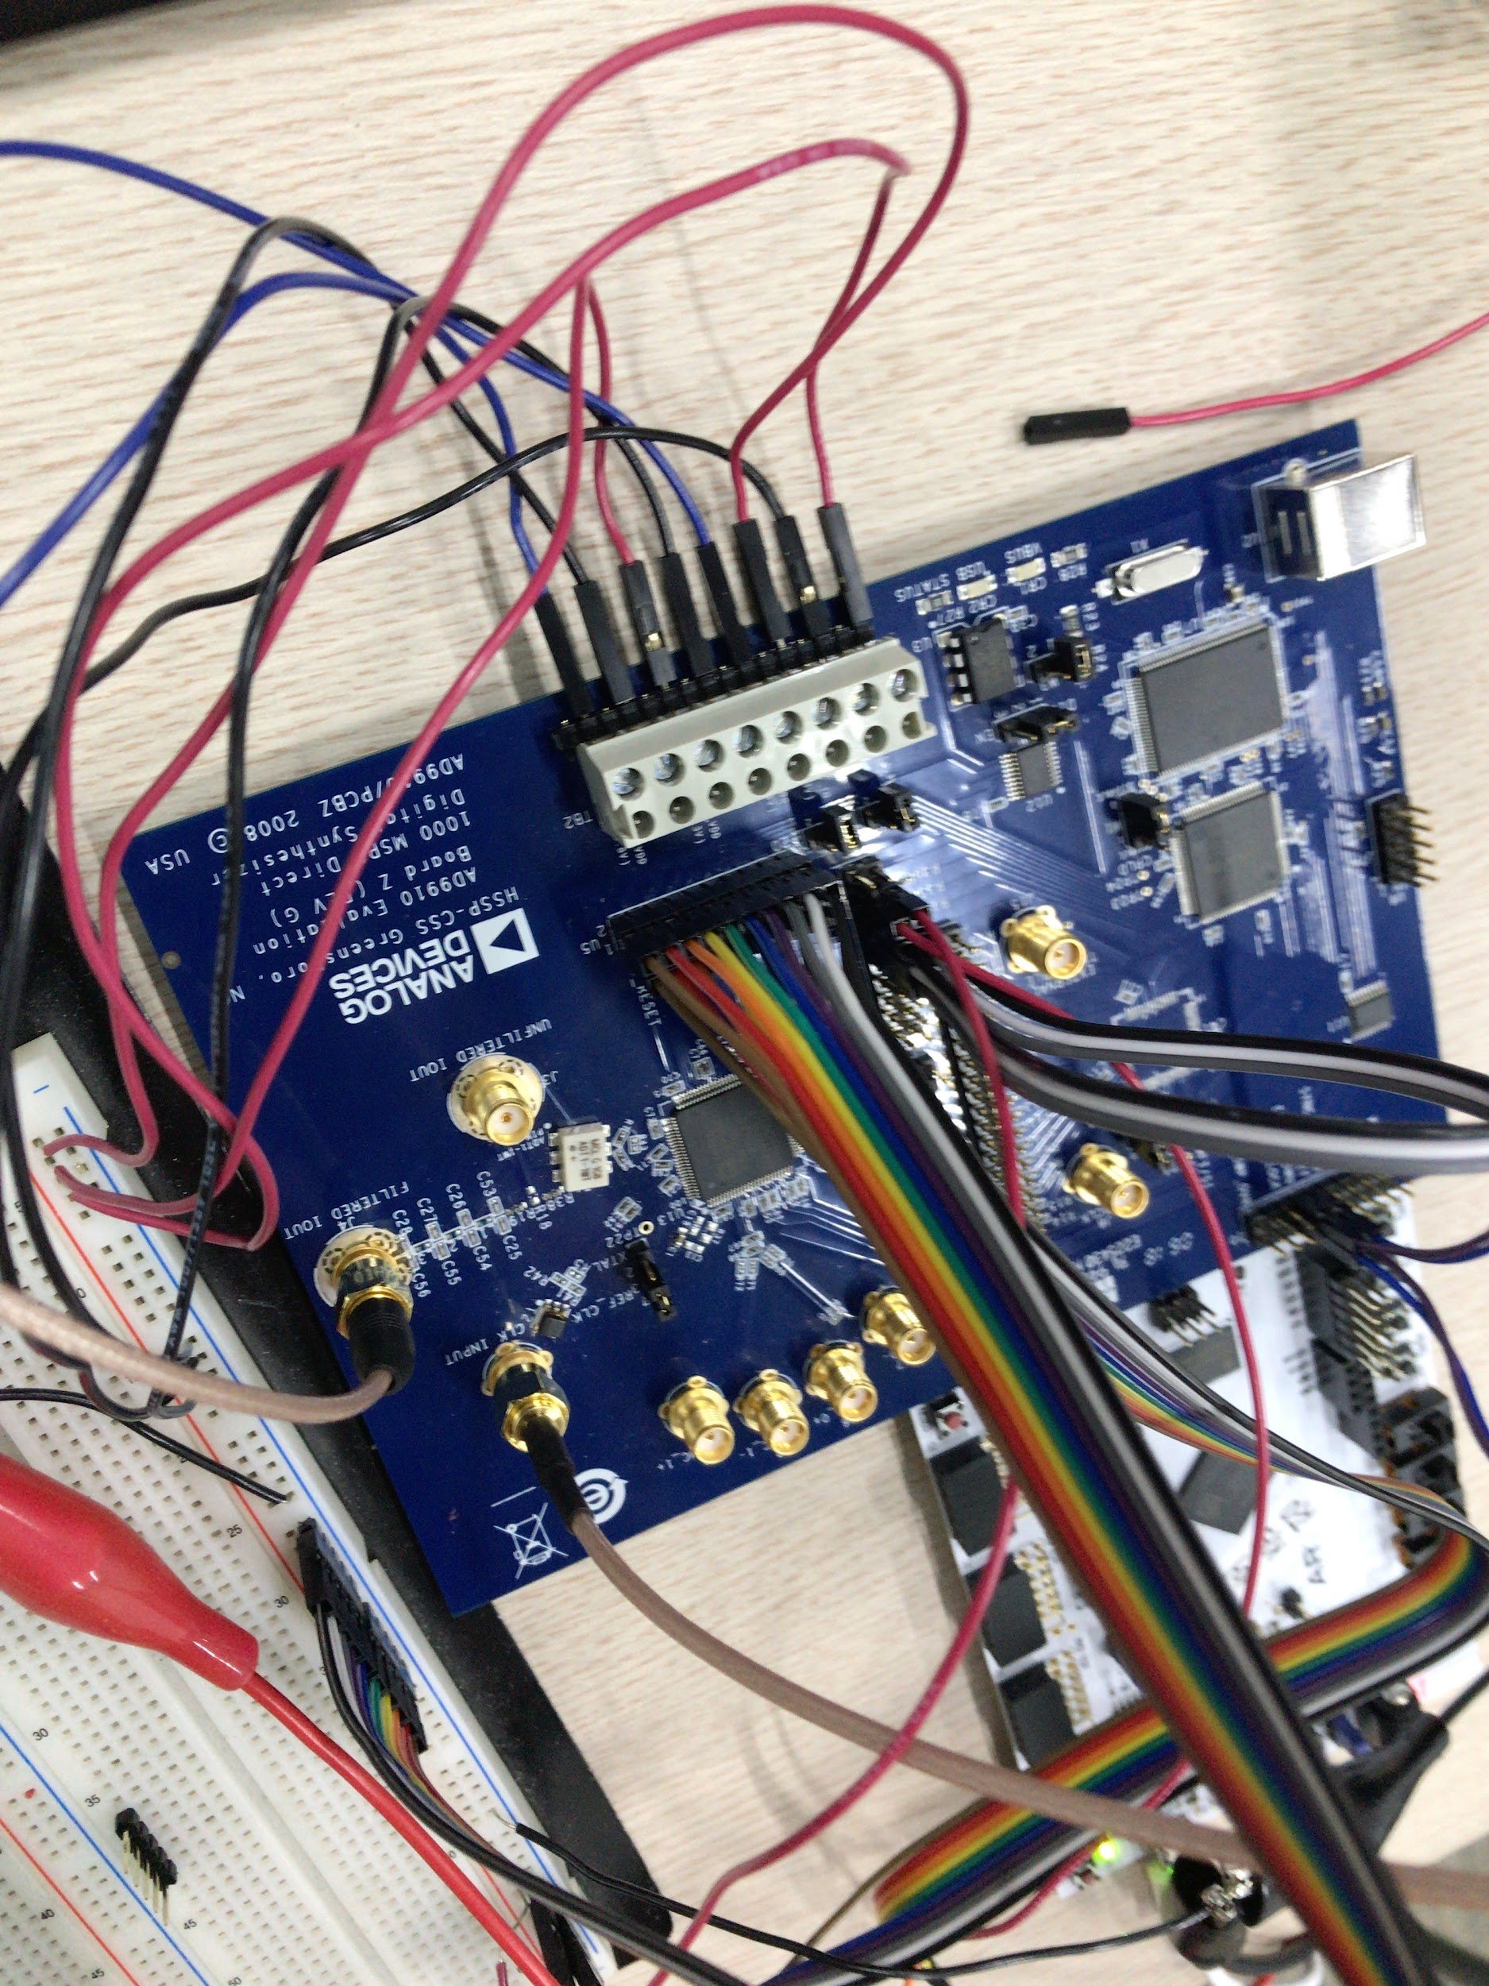

Figure16. Connection between U5 port and FPGA. Jumper connection should be changed when DDS board is controlled through FPGA. In this case, single tone mode is implemented and only profile0 is used, so all profile pins should be connected to ground.

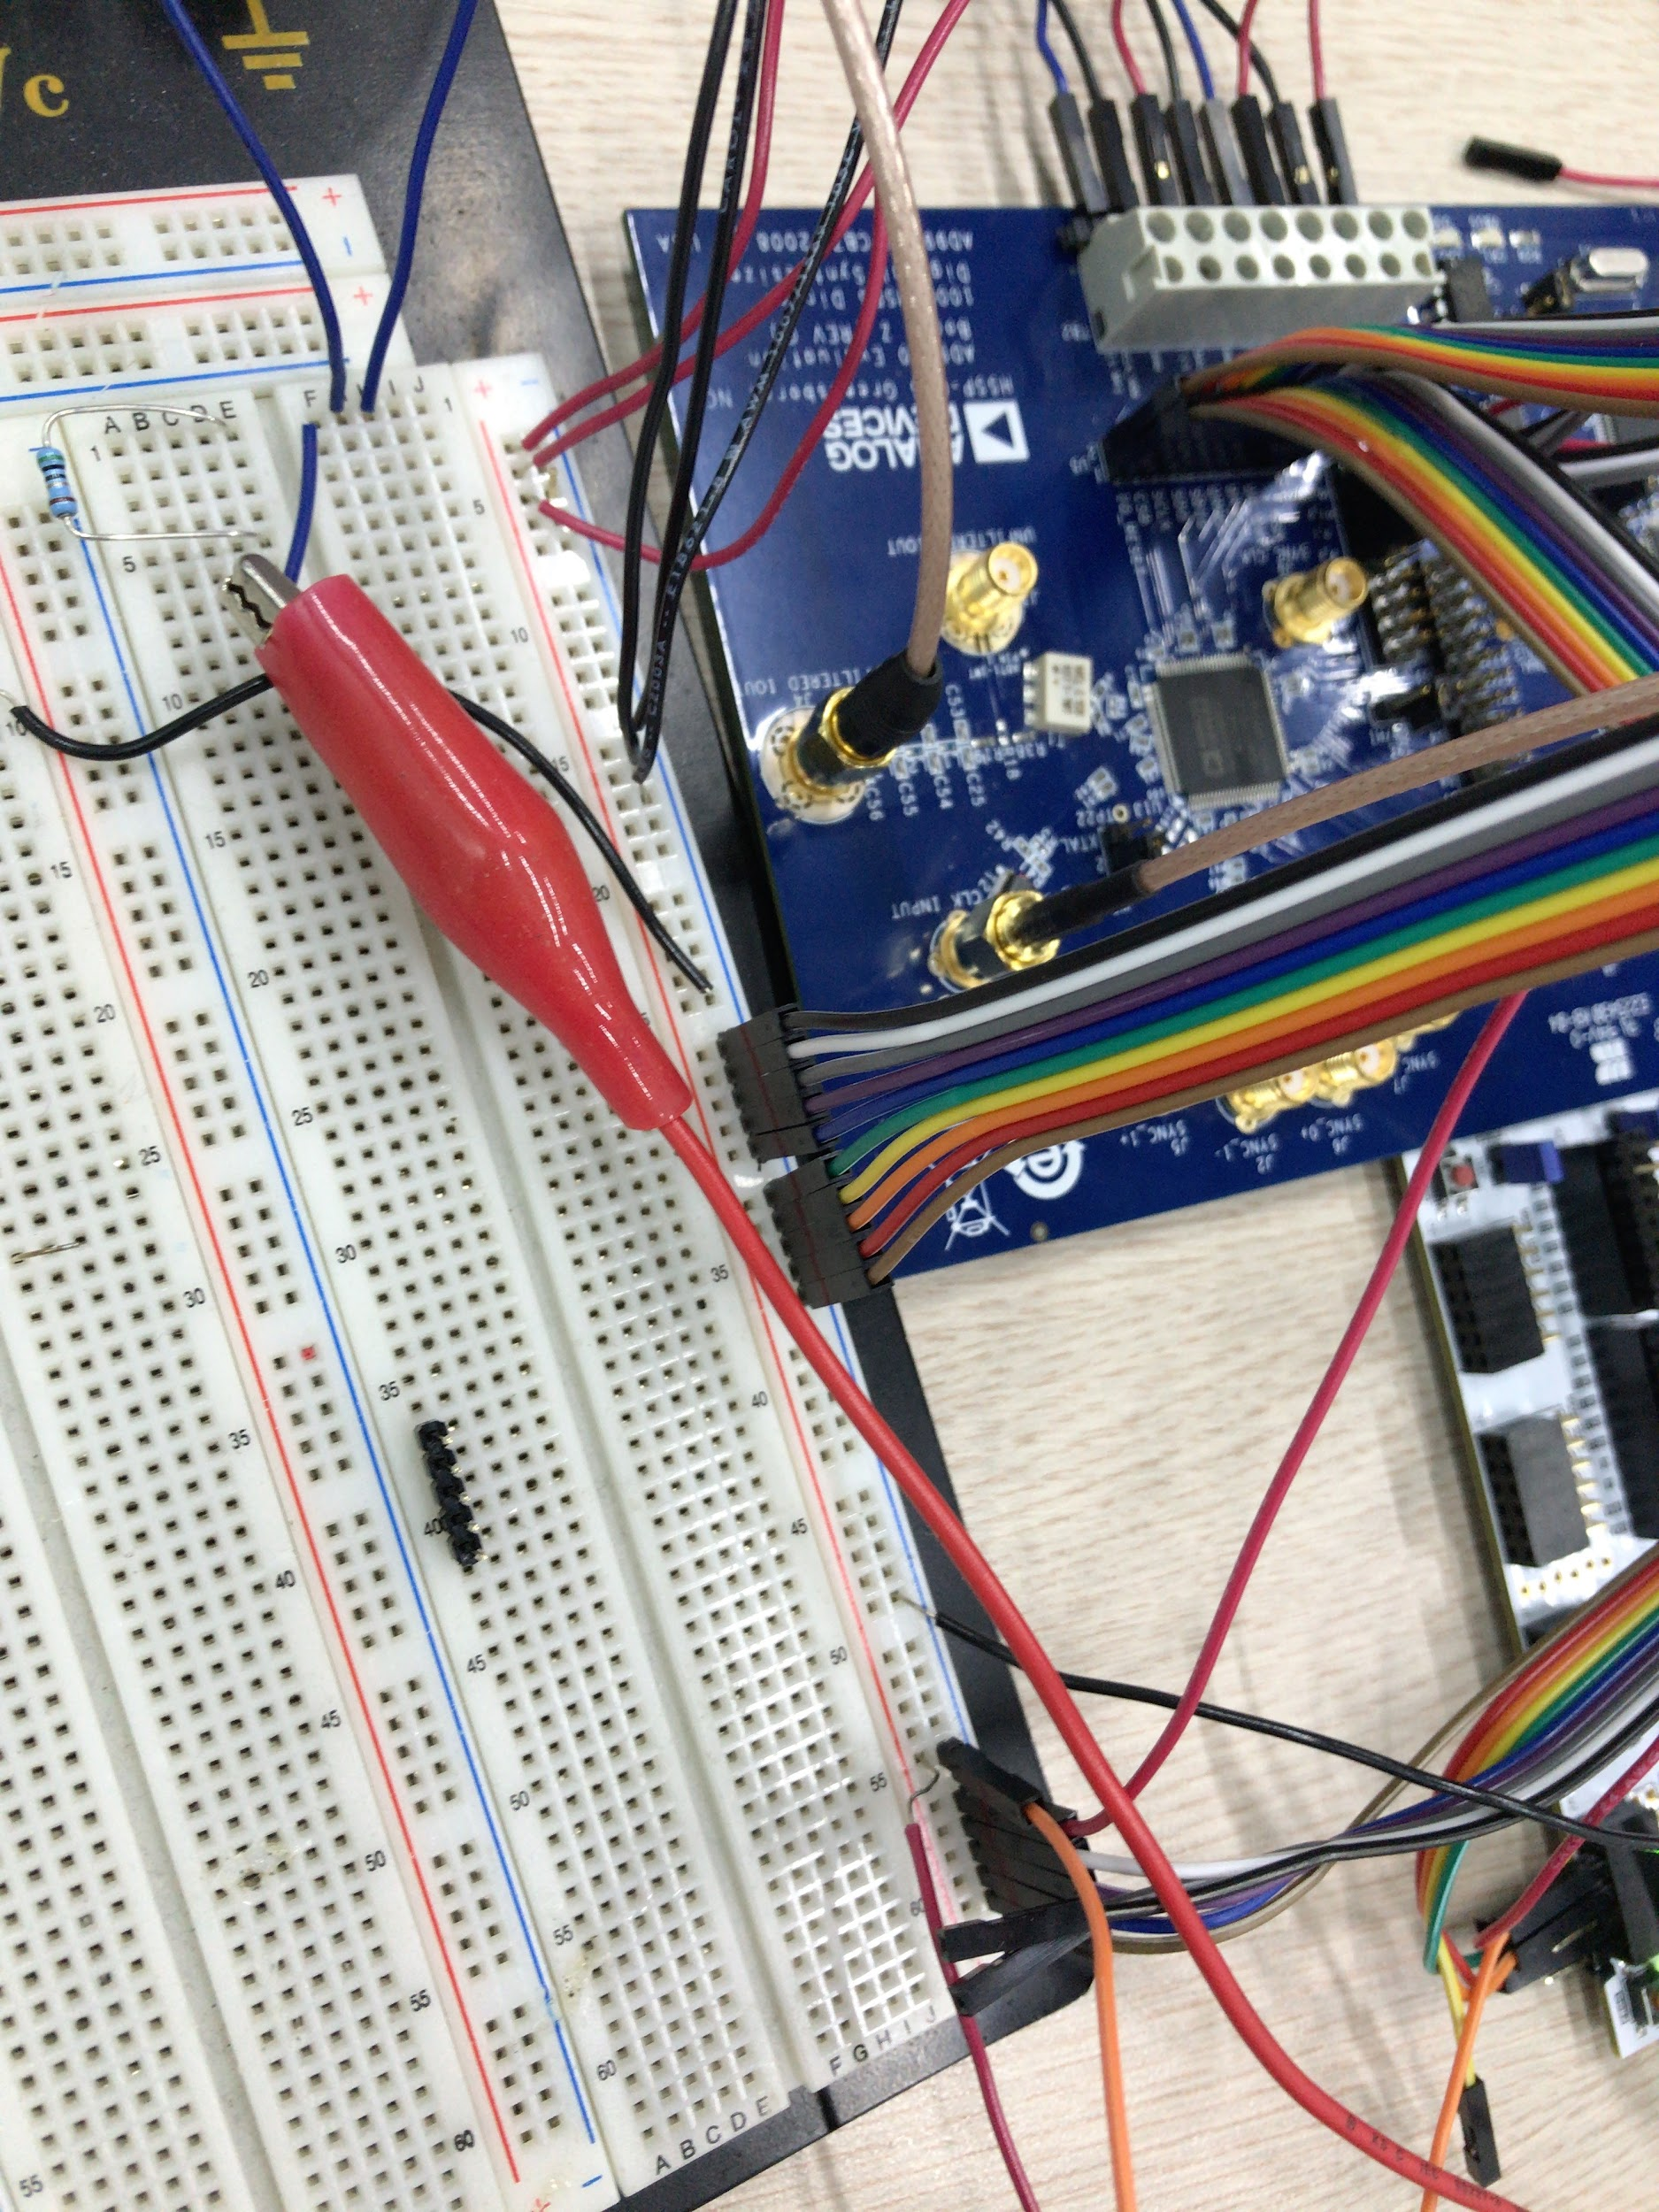

Figure17. Connection between evaluation borad and ground of DC power supply. FPGA ground is also connected to DC power supply ground.

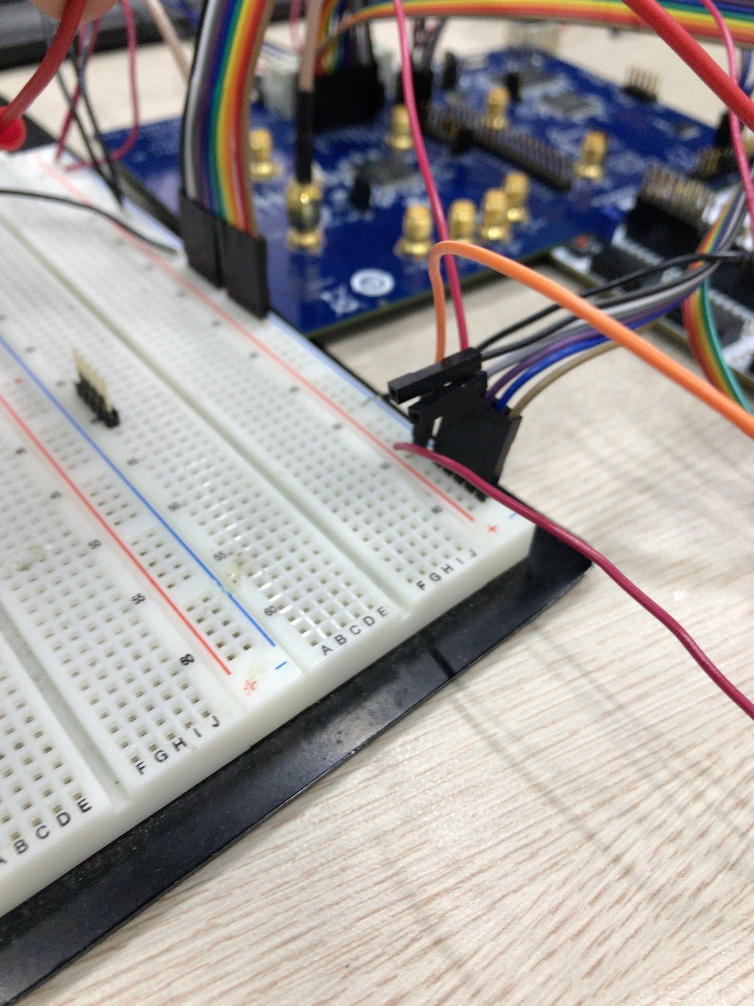

Figure18. Connection between FPGA and evaluation board pins. Only SDIO, SCK, CSB pins in U5 are connected to FPGA, other input pins(OSK, DR_CTL, DRHOLD, IO_RESET, SDO) are connected to ground. The others (DR_OVR, SYNC_CLK) is not connected to anything.

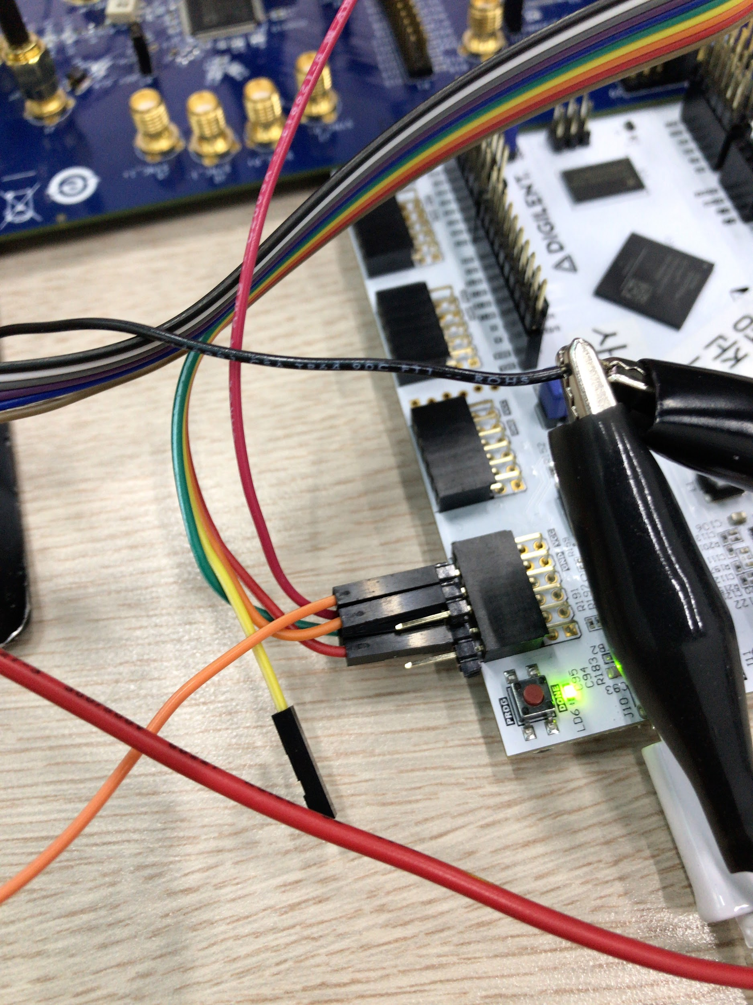

Figure19. Connection between FPGA and evaluation board. Only DDS1 port is used in this test.

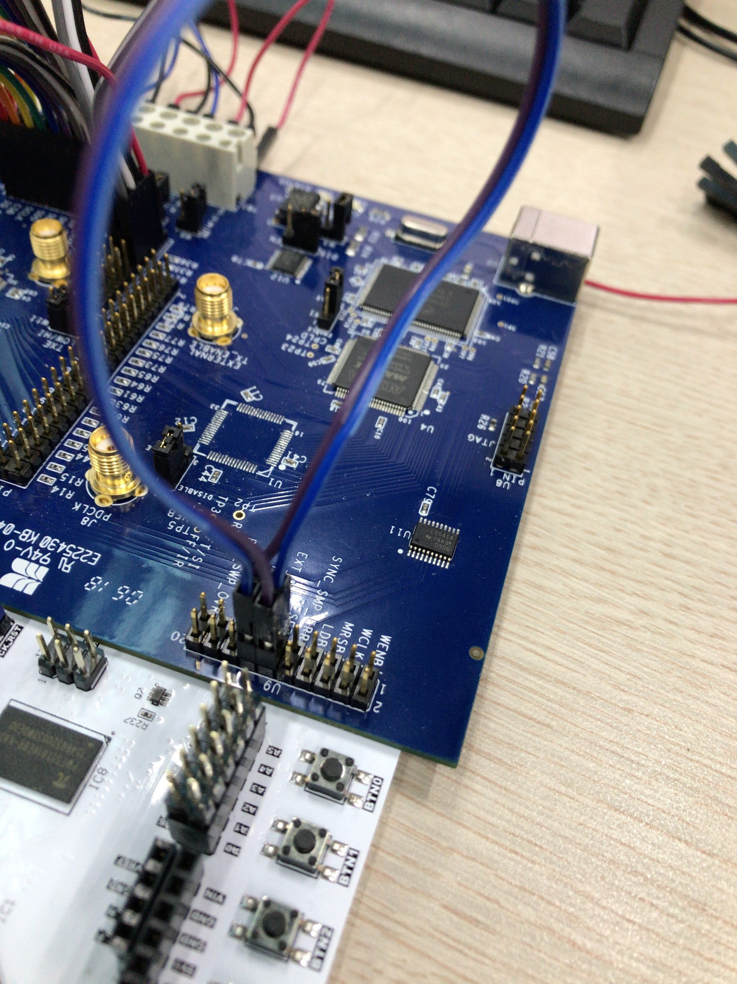

Figure20. Connection in U9 port. RESET and EXT_PWR_DWN should be connected to ground.

Same signal generator, and DC supply setting used in Analog program control were employed except 1GHz output frequency of signal generator, and jumper setting of evaluation board. W1, W2, W4 jumpers should be set to DISABLE, and W5, W6, W3 should be removed on the evaluation board. W7 should be set to REF_CLK(since signal generator is used for reference clock) and W11 pin to middle(since TxE pin was not used). You should connect 4 pins in evaluation board(IO_UPDATE, CSB, SCLK, SDIO) to FPGA pmod pins(ja_7, ja_6, ja_5, ja_3). And other pins in U5(IO_RESET, SDO, DRHOLD, DR_CTL, DR_OVR, OSK, SYNC) should be connected to ground. In this case, only single tone mode was implemented, so profile pins in P1 interface should be connected to ground. And EXT_PWR_DWN, and RESET pins should be connected to ground. And connect oscilloscope and DDS board using SMA to BNC cable. To see simple output of DDS, turn on 'AD9910_EX.py' and implement [6], [5], [7], [5], [8], [5], [4] functions in order. Notice that [6], [5], [7], [5], [8], [5] functions set CFR1, CFR2, CFR3 register to single tone mode and send IO UPDATE signal to update register of DDS. If CFR setting is not conducted, there would be half of output frequency due to bypassing option of CFR. And implementing function [4] corresponds to setting profile register. If other profile different with profile 0 is set in this test, DDS output frequency would not be changed. And setting frequency, phase, and amplitude using [1], [2], [3] function will not work because these does set FTW, POW, ASF register which are not profile register. FTW, POW, ASF register work only when using RAM, DRG, and Parallel mode.

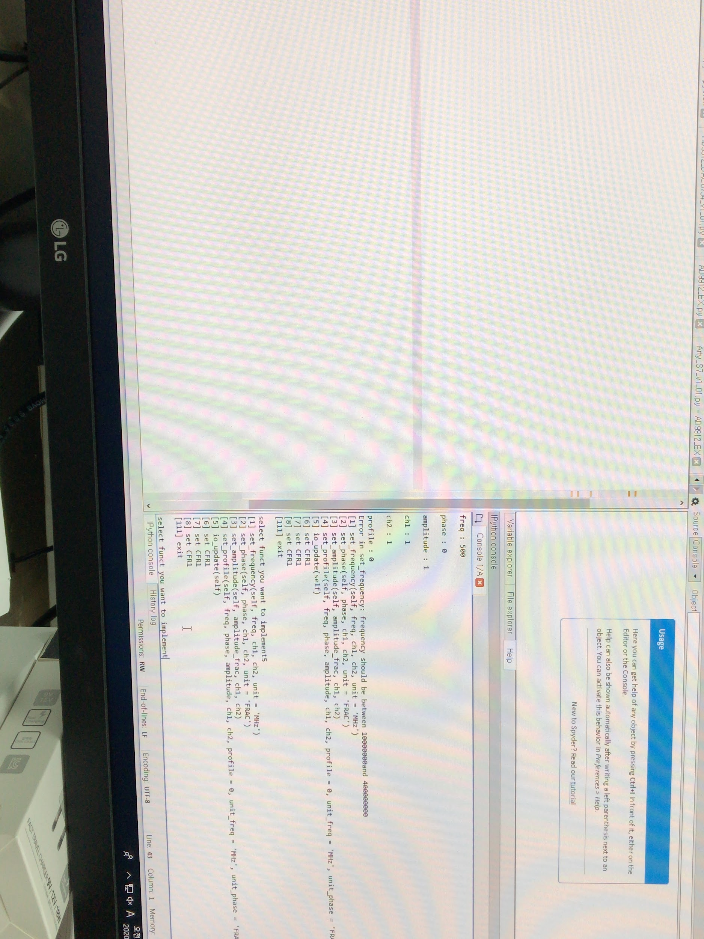

Figure21. Python program. Functions will be appeared on the screen.

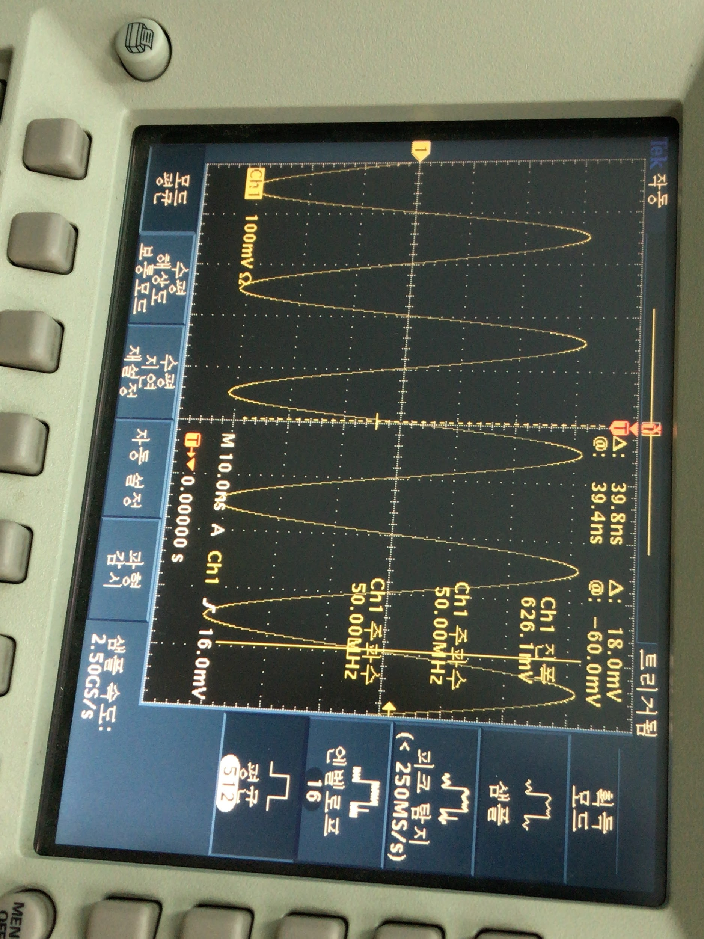

Figure22. Output measurement. In this case, amplitude is set to maximum.

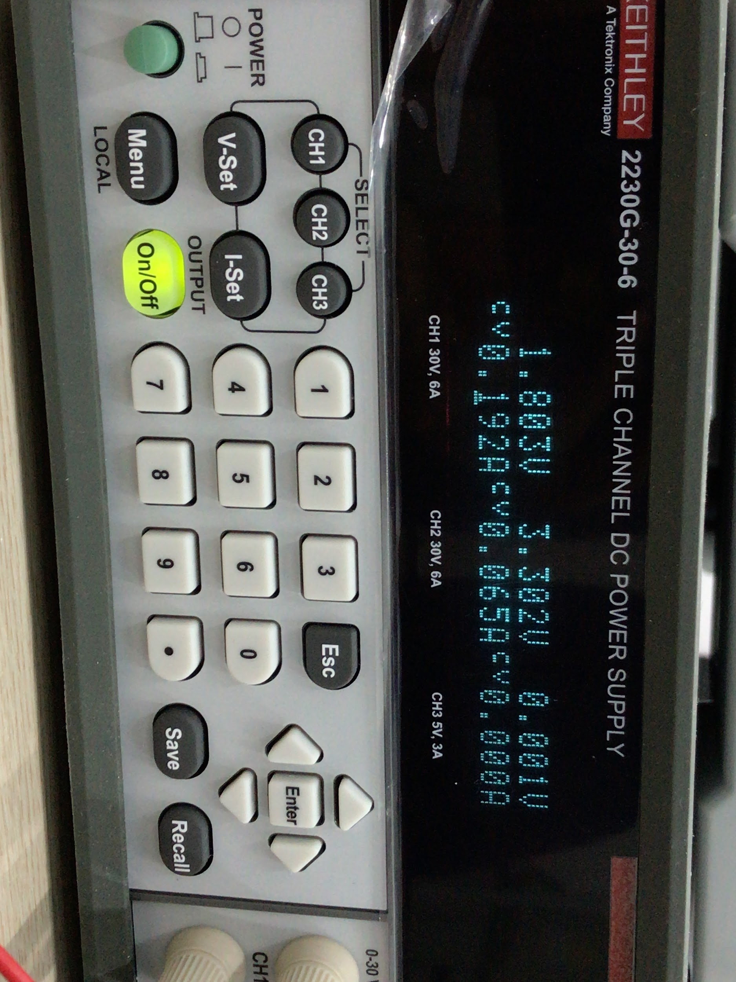

Figure23. DC power supply setting. If maximum current is set too low, output of DDS would not be clear.

# 2. New Design

## 2.1. Modified Architecture

New hardware architecture was made applying new design of sequencer partially and maintaining previous AD9912 FSM. Main differences of this design are FIFO which discharges signal at stated timestamp, gpo core and rto core which are based on new design of sequencer, and removal of DAC modules and WrightToRegister modules. DAC pins were replaced to AD9910 parallel output. Pins of jb and jc were also activated to supply profile and rest of parallel output signal. WrightToRegister module was replaced to new spi module which can set CPHA, CPOL, CSPOL, slave enable, length, 8 of cs, end SPI, LSB_FIRST, and clock divide. Each equal to clock phase, clock polarity, chip select polarity, whether to read or not, length of SPI signal, whether to end SPI communication, whether signal is based on lsb first or not, and ratio between FPGA clock and SPI clock. So, any SPI mode can be conducted and degree of freedom is extended. And, depending on slave enable DDS register can be read. Almost data read or write in AD9910 is 32 bit, 64 bit, so 32, 64 bit wirte, read function is implemented on AD9910.py. Additionally, override functionality is implemented in gpo_core module, so driving FPGA without FIFO is possible. Notice that WrightToRegister module is removed and length of SPI data is set in SPI configuration, so length of data is not included to BTF_list(so 64 bits needs list of length 8, and 128 bits needs list of length 16). Moreover, BTF_list should be composed in little endian. For example, 0x0123456789ABCDEF data should be converted to [EF, CD, AB, 89, 67, 45, 23, 01] in list.

There are some differences with new sequencer. First, new sequencer is based on memory mapped IO, while this is not. However, memory mapped IO can be easily implemented adding some register outside of gpo_core_prime, rto_core_prime, rti_core_prime. In addition, while 32 bit is employed as a unit data in new sequencer, 128 bit and 64 bit are used in this case. Second, there are error signals informing which type of error and data have occurred. There are 5 types of error signal: overflow error, timestamp error, overrided, busy error, and underflow error. Overflow error indicates that FIFO in rto_core or rti_core is overflowed. And error data corresponds to data which is not written to FIFO. Timestamp error indicates that timestamp of data in the top of FIFO is less than counter. Error data corresponds to this top data and this will be dismissed. Overrided indicates that override value and new FIFO output with timestamp match came to gpo_core coincidently. Error data corresponds to FIFO data, and override value would be discharged from gpo_core. Busy error indicates that new data either override value or FIFO output arrived while output port is in busy state. In this case error data corresponds to new income, output of gpo_core would not be changed and selected pulse would not be made. FIFO output has higher priority than override data in error data. Microarchitecture of new design is as follows.

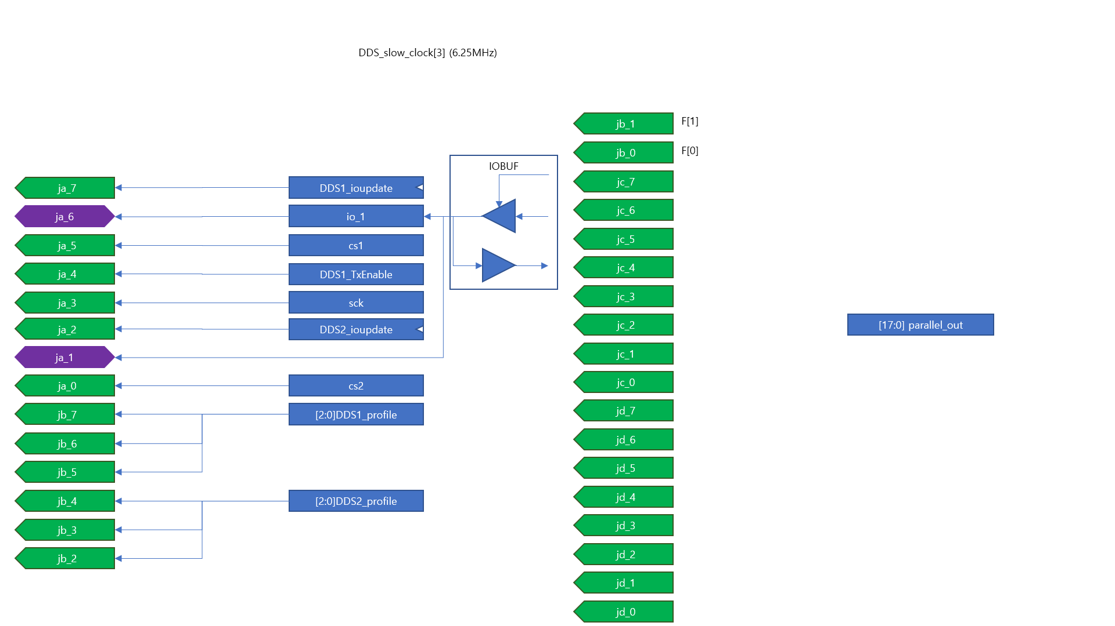

Figure24. New pin arrangement. IOBUF was used to make read possible

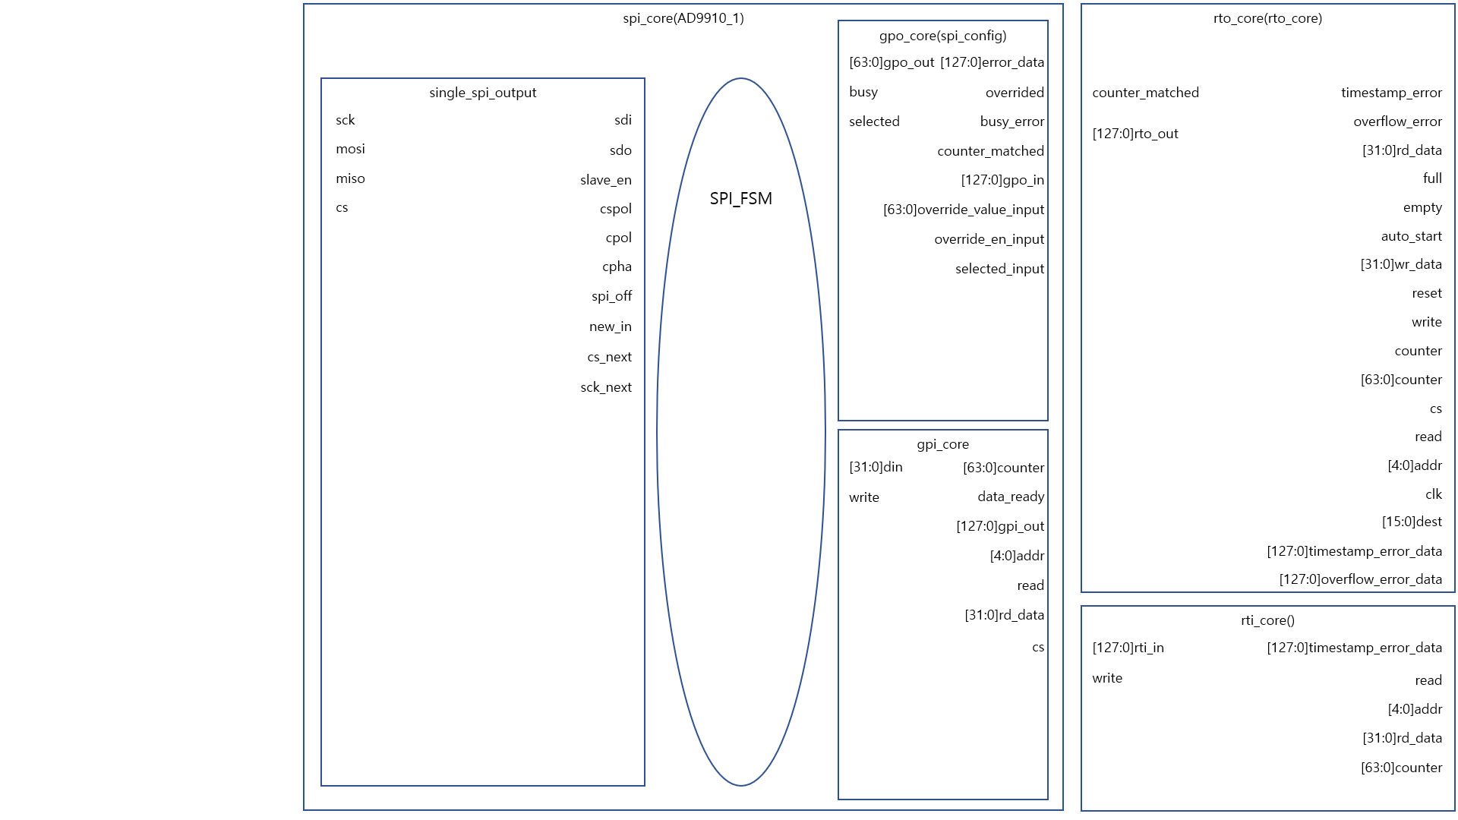

Figure25. Block diagram of AD9910 driver

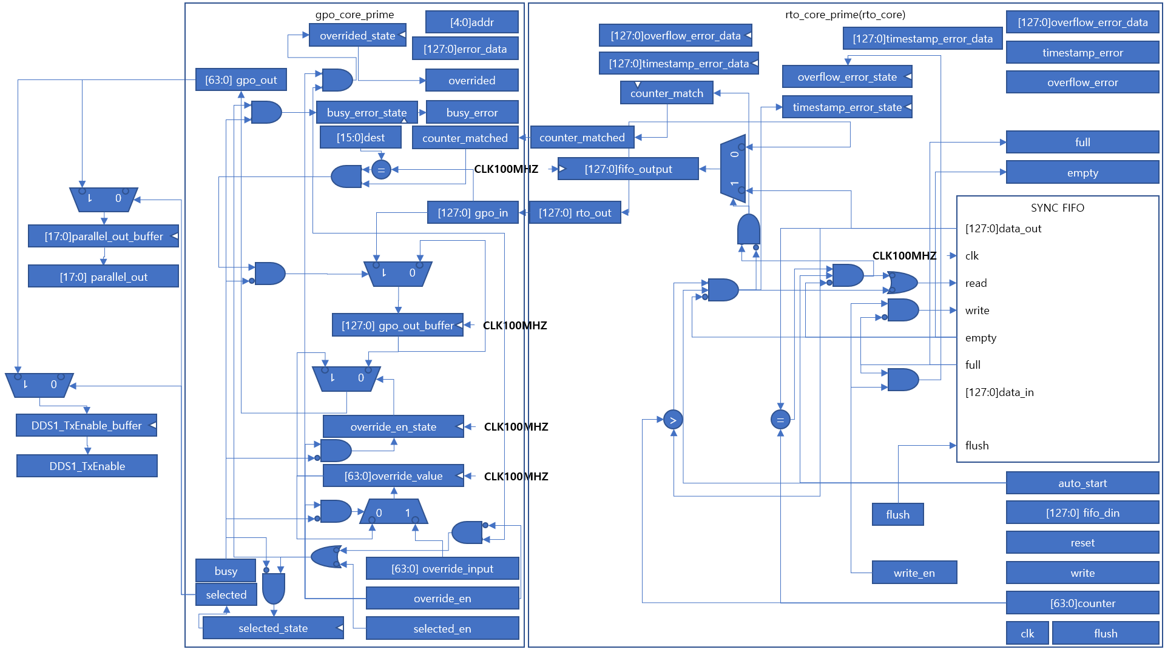

Figure26. Microarchitecture of gpo_core_prime and rto_core_prime

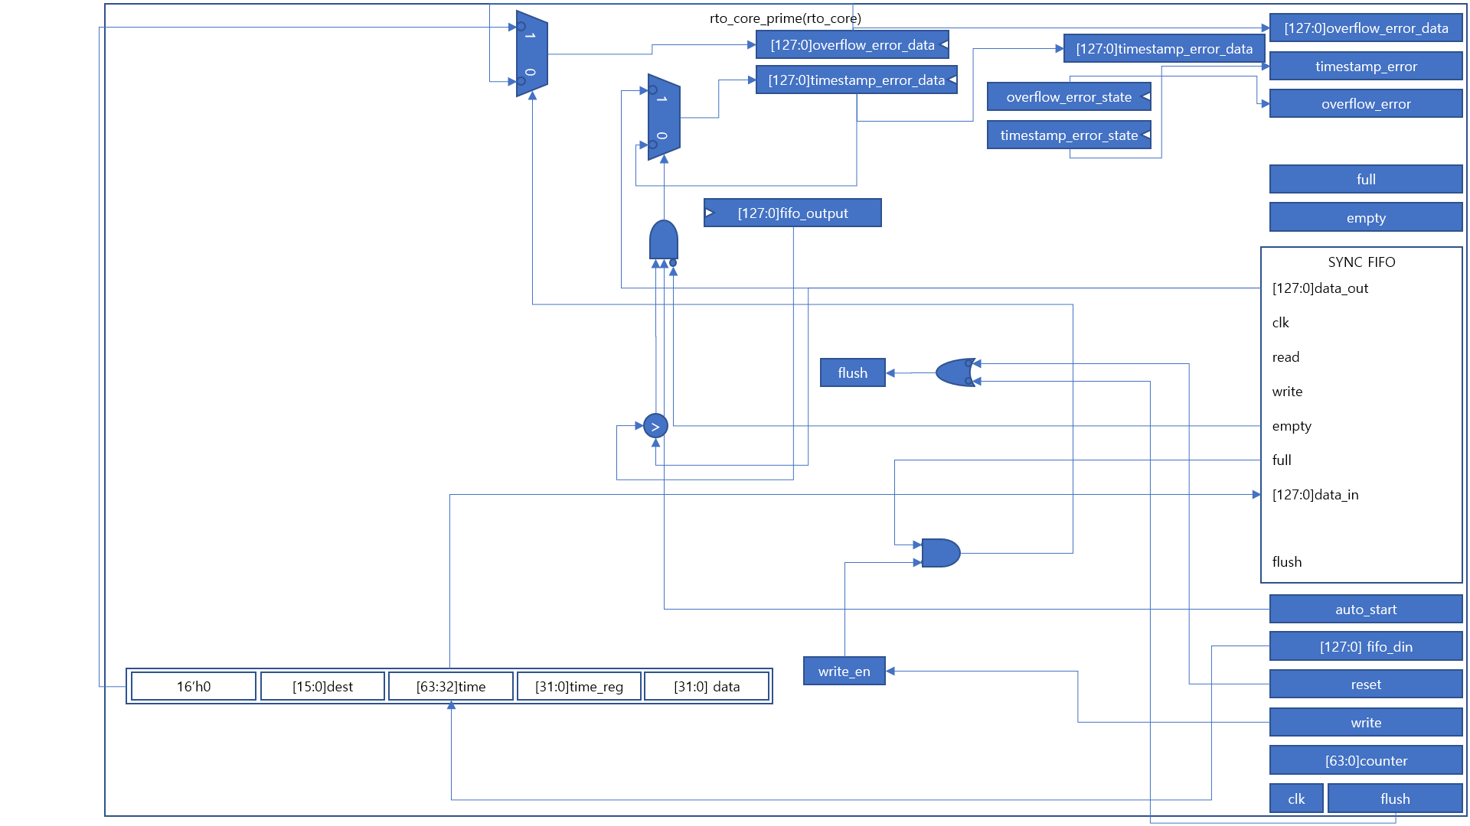

Figure27. Microarchitecture of rto_core_prime

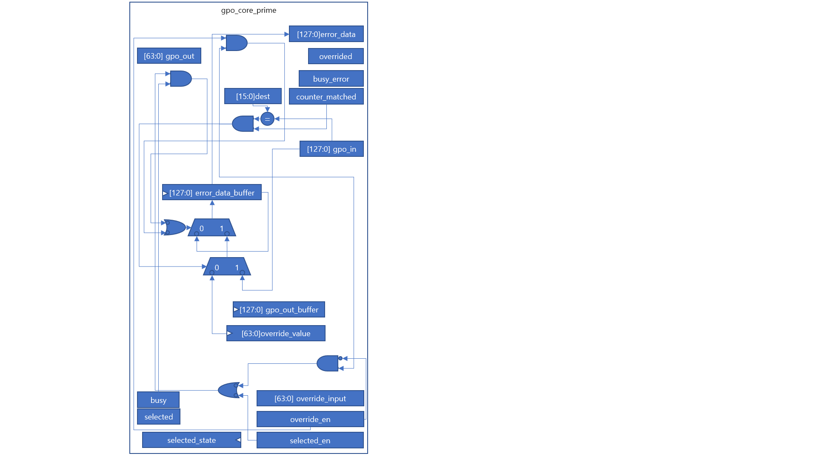

Figure28. Mircoarchitecture of gpo_core_prime

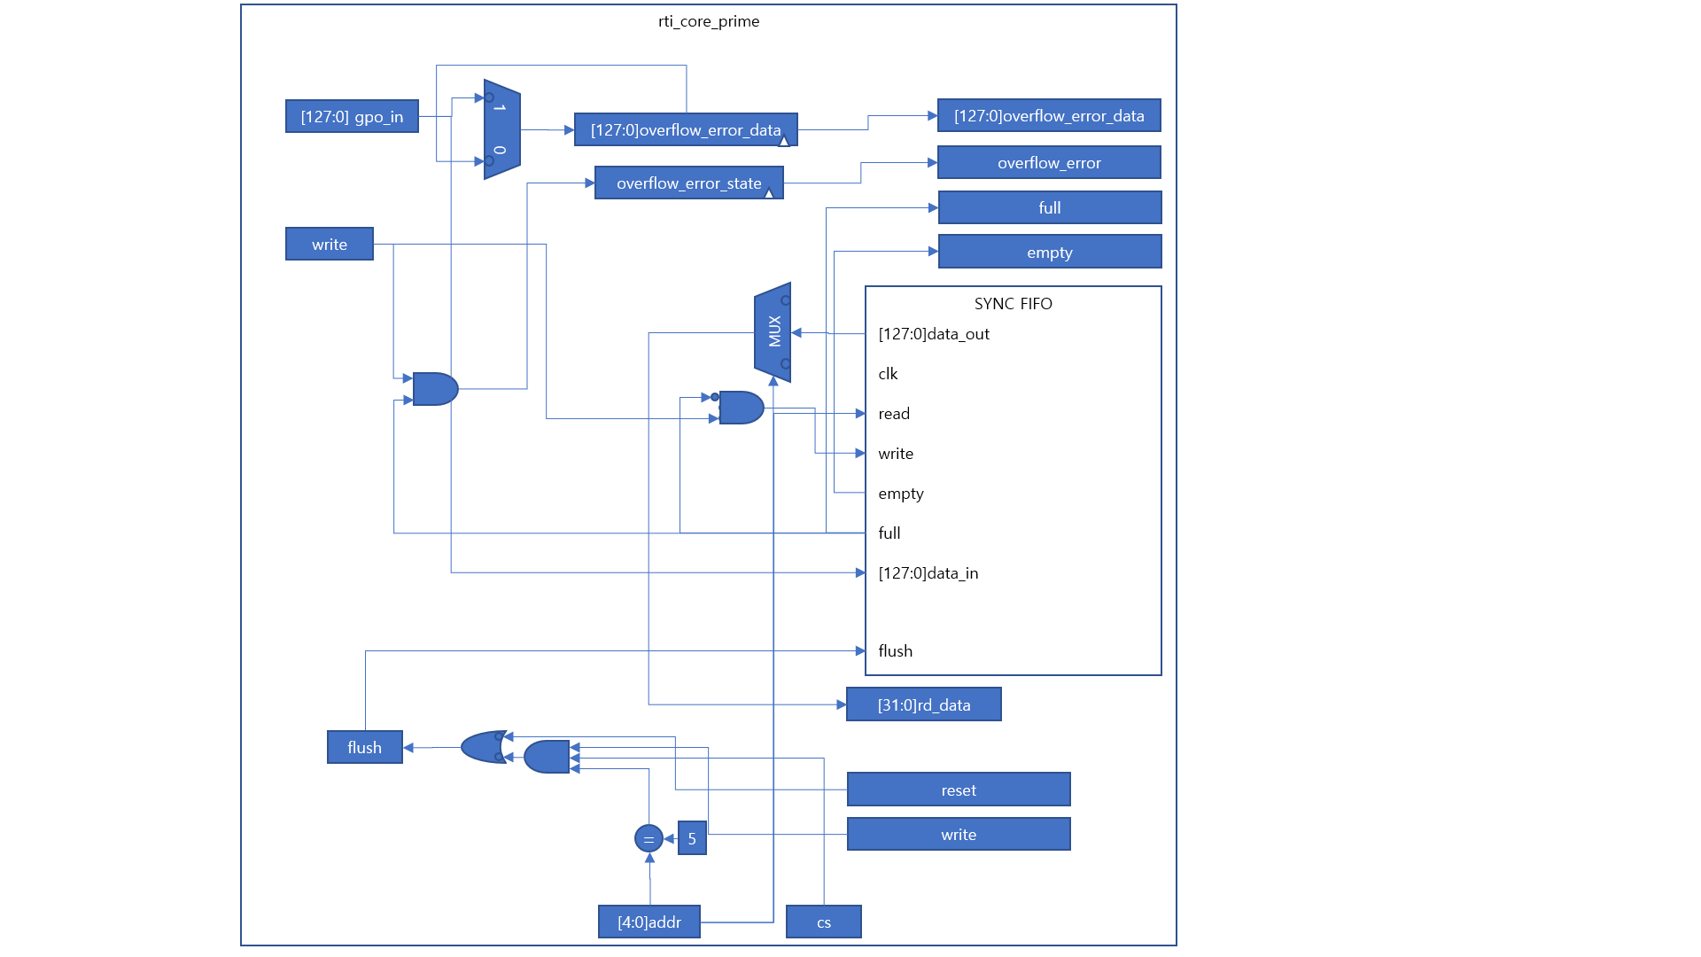

Figure29. Mircoarchitecture of rti_core_prime

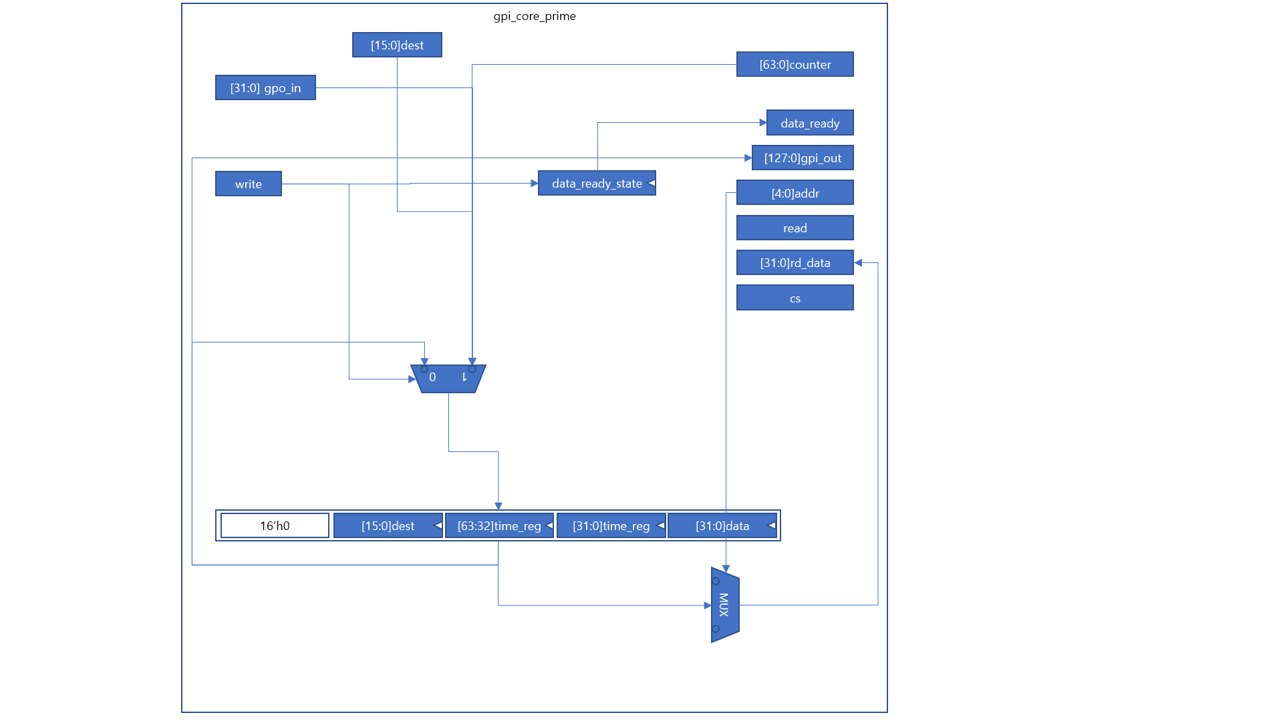

Figure30. Mircoarchitecture of gpi_core_prime

## 2.2. Modified Function

New Python program was made due to new design of hardware. Previous python code employs fixed length (9 bytes) for all DDS, however new python code uses 8 bytes in override mode, and 16 bytes in auto mode. Auto mode discharge signal at stated timestamp and override functionality makes realtime output. Auto mode and override functionality can be set using function **auto_mode()** and **override_enable()** each. In the same way each can be disabled using **auto_mode_disable()** and **override_disable()**. In auto_mode, timestamp will be added to instruction according to time value in AD9910 object. Timestamp value can be shifted using **delay_cycle(shift_time)** and **delay(shift_time)** function. Notice that parameter of **delay_cycle** method has unit of clock cycle, while **delay** method has unit of seconds. For example, **delay_cycle(10)** is equal to **delay(100 * ns)** since one cycle is equal to 10ns in ArtyS7. And, using function of AD9910 would not change timestamp value, so you have to consider set proper time delay not to make busy error or timestamp error.

Previous method of AD9910 employs parameter **unit** to indicate which unit is used in frequency, phase etc. However in new program, writing proper unit and asterisk(‘*’) next to number like in ARTIQ is implemented. For example, 100 MHz can be written as **100 * MHz**. Available unit is written in unit_set.py so importing unit_set.py is necessary.

## 2.3. Simulation on Verilog

In Arty_S7_v1_01.py, there is TEST variable which indicate whether program is used for simulation and does not implement serial communication or real experiment. If TEST is set to 1, signal wouldn't be discharged from PC to FPGA and this would be printed on screen and written as a file 'test_output.txt' simultaneously. 'test_output.txt' can be converted to part of Verilog simulation codes employing 'uart_convertor.py'. Using this codes, simulation of python code on the Verilog code is possible. Notice that UartRx is set to high before any data received, and become low for 17361 cycles (according to baudrate set to FPGA) after data received. After 8 bits of data is sent, UartRx should be set high for 17361 cycles. Notice that proper time to see available output is almost 50ms, and it would takes some time(2~3 minutes) and big storage resource(order of GB).

# 3. New Board Design

## 3.1. Board Layout

AD9910 pin layout is shown beyond figure.

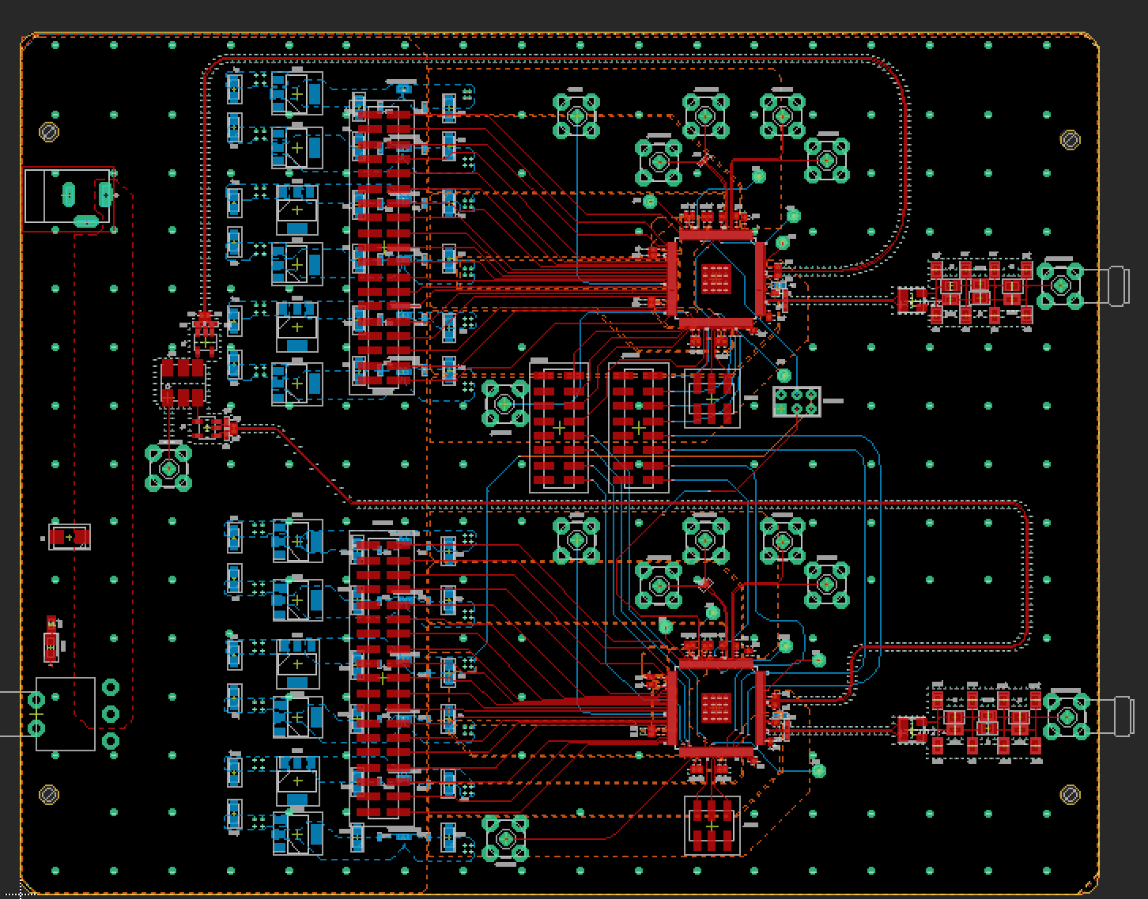

Figure.

Simplified pin layout which need to be connected to FPGA is shown in beyond figure.

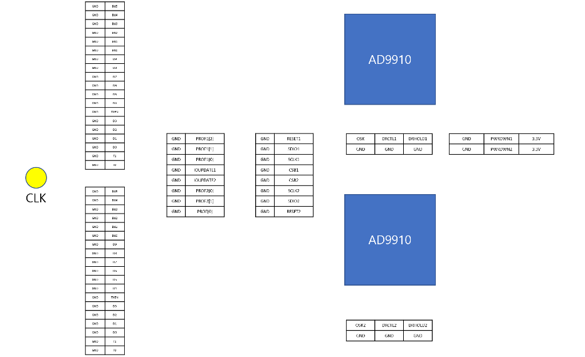

Figure.

FPGA pin layout is as follows. If you are intended to use only one of AD9910(e.g. upper side AD9910 chip) you need not connect red box pins. In addition FPGA pins for PARALLEL mode is not shown, so it requires ArtyS7 PMOD c,d pins connected to parallel pins to use PARALLEL mode.

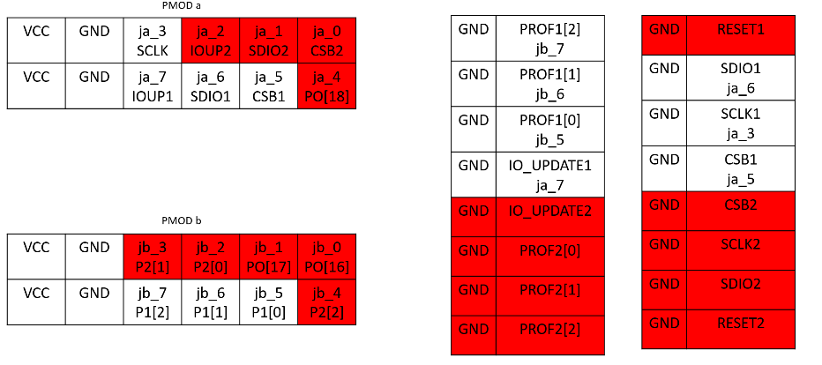

Figure.

For single tone mode or ram mode, you have to notice that specific pins must be grounded as beyond figure. Orange box stands for ground head.

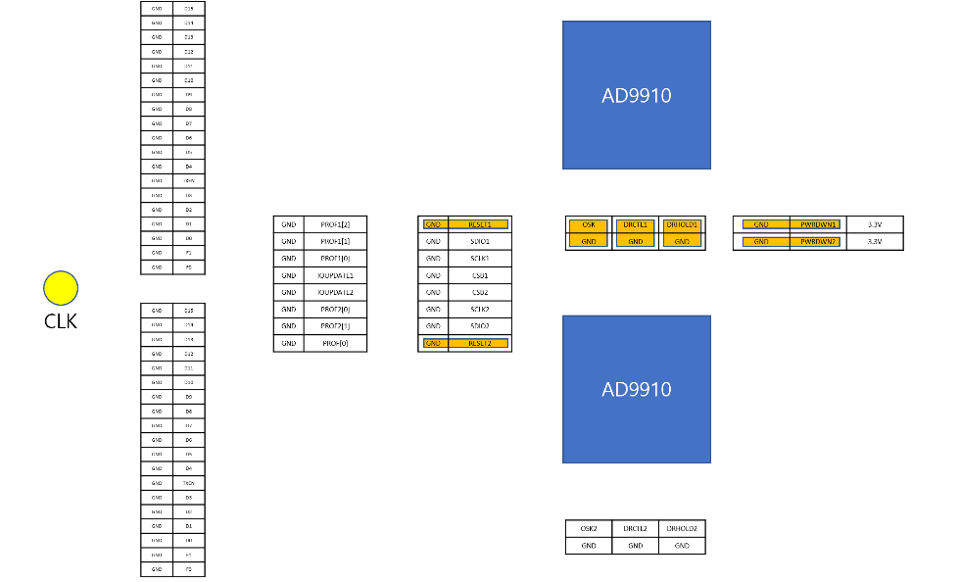

Figure.

In addition front PWR_DWN pin and RESET pin must be grounded as layout. If not, it will not work since floating pin would make AD9910 chip malfunction. In addition notice that FPGA ground pin should be connected to AD9910 board ground, and you should program bit file to FPGA before you turn on the AD9910 board due to CSB signal should be HIGH when AD9910 is not being programed.

Clock frequency could be set up to 1GHz, and proper output power is 13dBm to supply 10dBm for each AD9910 chip. Notice that when clock source is power down, then AD9910 chip discharge 300MHz signal. In addition, you should set peak-to-peak voltage of clock source to zero before turn off the clock source not to damage the clock source device.

## 3.2. Profile Pin Glitch Problem

New AD9910 board is tested through 2023.01.01 to 2023.02.03. There was PROFILE pin glitch problem in AD9910 chip. Ideally, changing PROFILE signal makes internal register to be updated from buffer registers, and changing PROFILE value 0b000 to 0b111 does not make problem. However in experiment, changing more than one PROFILE bit simultaneously does not work properly. For example sending PROFILE signal from 0b000 to 0b011 changed PROFILE register from 0b000 to 0b010 or 0b001 randomly. It was determined that problem was came from set – hold timing problem. To solve this problem you should send IO_UPDATE signal to AD9910 chip manually to update internal register of AD9910.

Digital signal timming is shown below figure assuming D flip flop with synchronous clock. Simplified D flip-flop is shown as right figure. Positive clock edege makes switch S1 close and S2 open. At this moment input voltage charges capacitor C. After positive clock edge, S1 open and S2 close, then feedback circuit amplify output and maintain its value whenever supply voltage donnot turn off. However, if input voltage has value between LOW and HIGH it would makes longer to output voltage to get LOW, HIGH value. This phenomenon is called meta-stable, and you can see more details in Howard Johnson, High-speed signal propagation.

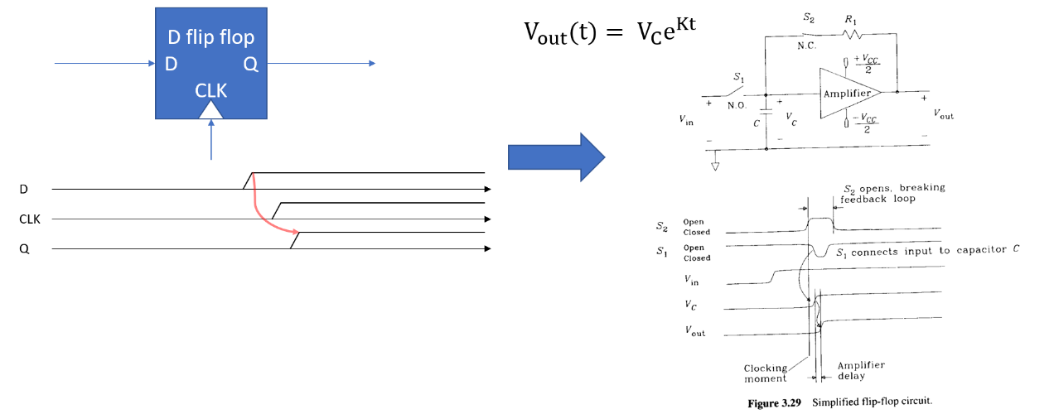

Figure.

PROFILE signal timming diagram is as follows. Ideally second pusle of SYNC_CLK makes profile register update. However changing PROFILE signal also works as a clock positive edge, and sending this signal as a input and clock signal sets setup-hold violation point itself, so input value always change its value in setup-hold regon. This would make meta stable or flip flop not to change their state.

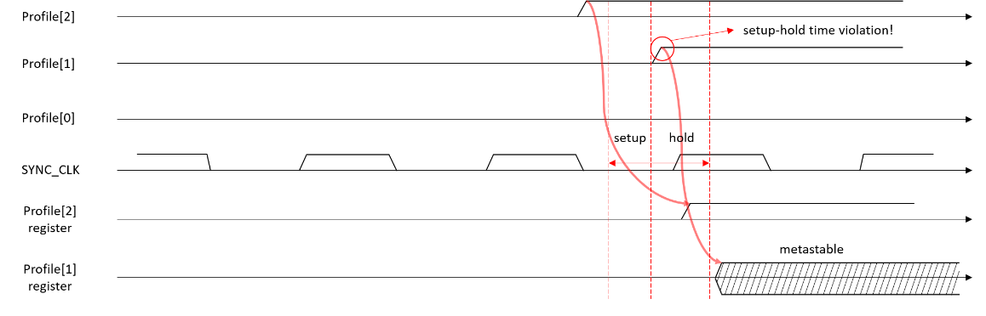

Figure.

AD9910 has a two kind of register, which is called buffer register, and internal register. Buffer register accept input signal and save value when IO_UPDATE signal is set, or PROFILE signal change their value. Internal reigster supply actual data to AD9910. Buffer register value get into internal register with SYNC_CLK, whose frequency is equal to 1/4 SYS_CLK. Timing diagram of this is as follows.

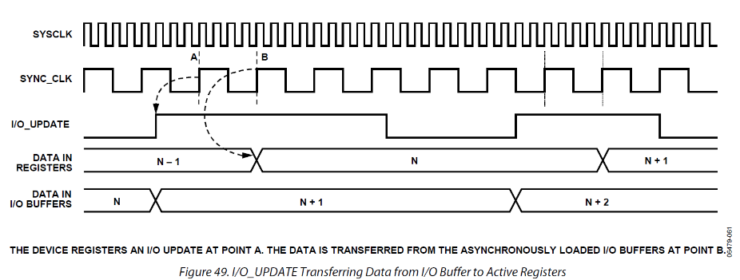

Figure.

Sending IO_UPDATE signal manually sets buffer register gets input from static value, so it fixs the glitch problem.

## 3.3. Implementation of RAM Mode

To implement RAM mode, you must write all RAM profile and RAM data according to RAM profile manually, whenever you use only one of profile. In addition, you have to write RAM data without **auto_mode** since RAM data can require more than 1024 data. Below code is example ram mode code suppling amplitude value from RAM.

|  |
| --- |
| **def** real_exp8(port):  dds = AD9910(ArtyS7(port))  #should reset driver before using override enable!!!!  dds.reset_driver()  #For Ram input, set ram_en = 0, and set auto mode disable & override enabled  dds.auto_mode_disable()  dds.override_enable()  dds.set_now_cycle(0) |

Do send ram data from PC to AD9910 directly through FPGA, set FPGA to override_enable, which send command without FIFO.

|  |
| --- |
| dds.set_profile_pin(profile1 = 0, profile2 = 0)    #set frequency register  dds.set_frequency(ch1 = 1, ch2 = 0, freq = 100 * MHz)    #set phase register  dds.set_phase(ch1 = 1, ch2 = 0, phase = 0)    #set amplitude register  dds.set_amplitude(ch1 = 1, ch2 = 0, amplitude_frac = 0.0) |

Set DDS frequency, phase, amplitude register, which are not supplied from RAM.

|  |
| --- |
| amplitude_list = [0.0, 0.1, 0.2, 0.3, 0.4, 0.5, 0.6, 0.7, 0.8, 0.9, 1.0]    dds.set_CFR1(ch1=1,ch2=0, ram_en = 0, ram_playback = 2, manual_OSK = 0,  inverse_sinc_filter = 0, internal_porfile = 0, sine = 1,  load_LRR = 0, autoclear_DRG = 0, autoclear_phase = 0,  clear_DRG = 0, clear_phase = 0, load_ARR = 0, OSK_en = 0,  auto_OSK = 0, digital_power_down = 0, DAC_power_down = 0,  REFCLK_powerdown = 0, aux_DAC_powerdown = 0,  external_power_down_ctrl = 0, SDIO_in_only = 0,  LSB_first = 0)    dds.set_CFR2(ch1=1,ch2=0, amp_en_single_tone = 0, internal_IO_update = 0,  SYNC_CLK_en = 0, DRG_dest = 0, DRG_en = 0,  DRG_no_dwell_high = 0, DRG_no_dwell_low = 0, read_eff_FTW = 1,  IO_update_rate = 0, PDCLK_en = 0, PDCLK_inv = 0, Tx_inv = 0,  matched_latency_en = 0, data_ass_hold = 0, sync_val_dis = 1,  parallel_port = 0, FM_gain = 0)  dds.set_CFR3(ch1=1,ch2=0) |

Set DDS CFR reigster for RAM mode, except **ram_en = 0**. Notice that ram_en should be equal to 0 before all of RAM data written.

|  |
| --- |
| dds.io_update(1,0)    #set profile pin  dds.set_profile_pin(profile1 = 0, profile2 = 0)    #set ram profile to bidirectional ram mode with start address 0 to  #end address 16 with step rate 20  dds.set_ram_profile_register(ch1 = 1, ch2 = 0, addr_step_rate =100,  end_addr= 10,  start_addr=0, no_dwell_high=0, zero_crossing=0,  ram_mode_ctrl=2, profile=0)    #set ram profile to bidirectional ram mode with start address 0 to  #end address 16 with step rate 20  dds.set_ram_profile_register(ch1 = 1, ch2 = 0, addr_step_rate =100,  end_addr= 21,  start_addr=11, no_dwell_high=0, zero_crossing=0,  ram_mode_ctrl=2, profile=1)    #set ram profile to bidirectional ram mode with start address 0 to  #end address 16 with step rate 20  dds.set_ram_profile_register(ch1 = 1, ch2 = 0, addr_step_rate =100,  end_addr= 32,  start_addr=22, no_dwell_high=0, zero_crossing=0,  ram_mode_ctrl=2, profile=2)    #set ram profile to bidirectional ram mode with start address 0 to  #end address 16 with step rate 20  dds.set_ram_profile_register(ch1 = 1, ch2 = 0, addr_step_rate =100,  end_addr= 43,  start_addr=33, no_dwell_high=0, zero_crossing=0,  ram_mode_ctrl=2, profile=3)    #set ram profile to bidirectional ram mode with start address 0 to  #end address 16 with step rate 20  dds.set_ram_profile_register(ch1 = 1, ch2 = 0, addr_step_rate =100,  end_addr= 54,  start_addr=44, no_dwell_high=0, zero_crossing=0,  ram_mode_ctrl=2, profile=4)    #set ram profile to bidirectional ram mode with start address 0 to  #end address 16 with step rate 20  dds.set_ram_profile_register(ch1 = 1, ch2 = 0, addr_step_rate =100,  end_addr= 65,  start_addr=55, no_dwell_high=0, zero_crossing=0,  ram_mode_ctrl=2, profile=5)    #set ram profile to bidirectional ram mode with start address 0 to  #end address 16 with step rate 20  dds.set_ram_profile_register(ch1 = 1, ch2 = 0, addr_step_rate =100,  end_addr= 76,  start_addr=66, no_dwell_high=0, zero_crossing=0,  ram_mode_ctrl=2, profile=6)    #set ram profile to bidirectional ram mode with start address 0 to  #end address 16 with step rate 20  dds.set_ram_profile_register(ch1 = 1, ch2 = 0, addr_step_rate =100,  end_addr= 87,  start_addr=77, no_dwell_high=0, zero_crossing=0,  ram_mode_ctrl=2, profile=7) |

Write all ram profile. If not, it would not work since without all ram profile written, changing profile pin makes write ram procedure.

|  |
| --- |
| #send ram data  #dds.ram_write_frequency(ch1=1,ch2=0,data_list = freq_list)    dds.set_profile_pin(profile1 = 0, profile2 = 0)  dds.io_update(1,0)  dds.ram_write_amplitude(ch1 = 1, ch2 = 0, data_list = amplitude_list)  dds.io_update(1,0)    dds.set_profile_pin(profile1 = 1, profile2 = 0)  dds.io_update(1,0)  dds.ram_write_amplitude(ch1 = 1, ch2 = 0, data_list = amplitude_list)  dds.io_update(1,0)    dds.set_profile_pin(profile1 = 2, profile2 = 0)  dds.io_update(1,0)  dds.ram_write_amplitude(ch1 = 1, ch2 = 0, data_list = amplitude_list)  dds.io_update(1,0)    dds.set_profile_pin(profile1 = 3, profile2 = 0)  dds.io_update(1,0)  dds.ram_write_amplitude(ch1 = 1, ch2 = 0, data_list = amplitude_list)  dds.io_update(1,0)    dds.set_profile_pin(profile1 = 4, profile2 = 0)  dds.io_update(1,0)  dds.ram_write_amplitude(ch1 = 1, ch2 = 0, data_list = amplitude_list)  dds.io_update(1,0)    dds.set_profile_pin(profile1 = 5, profile2 = 0)  dds.io_update(1,0)  dds.ram_write_amplitude(ch1 = 1, ch2 = 0, data_list = amplitude_list)  dds.io_update(1,0)    dds.set_profile_pin(profile1 = 6, profile2 = 0)  dds.io_update(1,0)  dds.ram_write_amplitude(ch1 = 1, ch2 = 0, data_list = amplitude_list)  dds.io_update(1,0)    dds.set_profile_pin(profile1 = 7, profile2 = 0)  dds.io_update(1,0)  dds.ram_write_amplitude(ch1 = 1, ch2 = 0, data_list = amplitude_list)  dds.io_update(1,0)      dds.set_profile_pin(profile1 = 0, profile2 = 0)  dds.io_update(1,0) |

Send RAM data from PC to DDS thorugh FPGA. Notice that you should set profile pin which you want to set. If all of RAM which is between address space of RAM profile is not written, it would not work since without all ram profile written, changing profile pin makes write ram procedure.

|  |
| --- |
| #########################################################  #set ram_en = 1  #########################################################  dds.set_CFR1(ch1=1,ch2=0, ram_en = 1, ram_playback = 2, manual_OSK = 0,  inverse_sinc_filter = 0, internal_porfile = 0, sine = 1,  load_LRR = 0, autoclear_DRG = 0, autoclear_phase = 0,  clear_DRG = 0, clear_phase = 0, load_ARR = 0, OSK_en = 0,  auto_OSK = 0, digital_power_down = 0, DAC_power_down = 0,  REFCLK_powerdown = 0, aux_DAC_powerdown = 0,  external_power_down_ctrl = 0, SDIO_in_only = 0,  LSB_first = 0)      dds.io_update(1,0)    dds.override_disable() |

Set ram_en = 1 in CFR register, then it works in RAM mode.

|  |
| --- |
| ##########################################################  #setting auto mode  ##########################################################  dds.auto_stop()  dds.set_now_cycle(0)  dds.reset_driver()  dds.auto_mode()    dds.delay_cycle(1000)  dds.io_update(1,1)    dds.delay_cycle(1000)  dds.set_profile_pin(profile1 = 1, profile2 = 0)    dds.delay_cycle(2000)  dds.set_profile_pin(profile1 = 0, profile2 = 0)    dds.delay_cycle(2000)  dds.set_profile_pin(profile1 = 1, profile2 = 0)    dds.delay_cycle(2000)  dds.set_profile_pin(profile1 = 0, profile2 = 0)  ###############################################################  #start auto mode  ###############################################################  dds.auto_start() |

Set FPGA to **auto_mode**, since all of RAM data is written. The output of DDS is as follows. Do measure amplitude change, you have to set trigger signal, for example IO_UPDATE of second AD9910, and set oscilloscope to single mode. Upon IO_UPDATE be active, oscilloscope show measured data close to trigger signal. The **dds.io_update(1,1)** code makes trigger signal in this experiment.

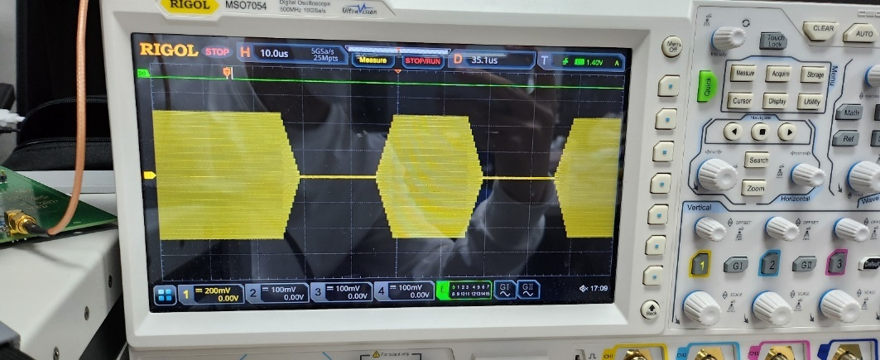

Figure.

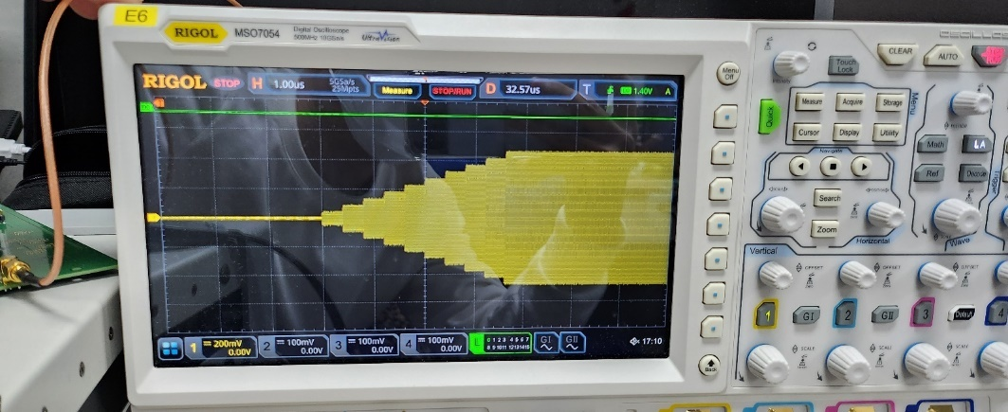

Figure.

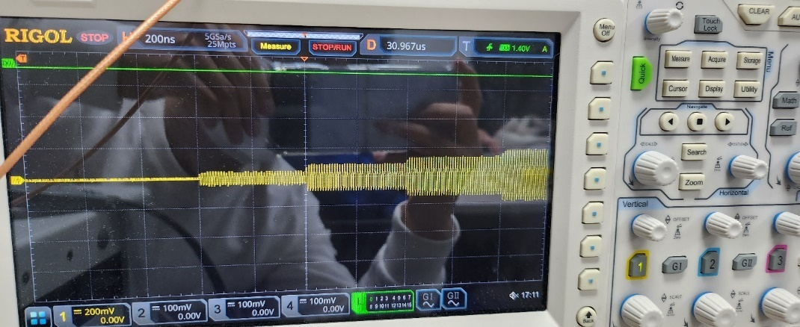

Figure.

## 3.4. Clock Trace Impedance Matching Problem

Characteristic impedance of PCB trace should be equal to termination impedance at start or end. If not, it would make reflection and distortion in signal. When impedance is matched in start termination, it should be connected as a series with line trace. AD9910 resistance input is 2600ohm, so just attachment of 50ohm to end termination would work properly. These configuration is shown below.

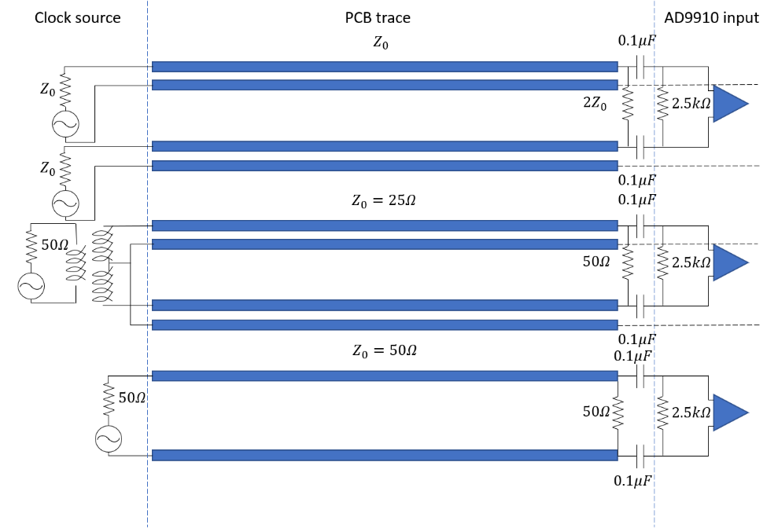

Figure.

On the other hand, it should be connected as a pallel with line trace when it is matched in start termination. In our case, however, termination resistor was attached at start termination of line trace parallely as follows.

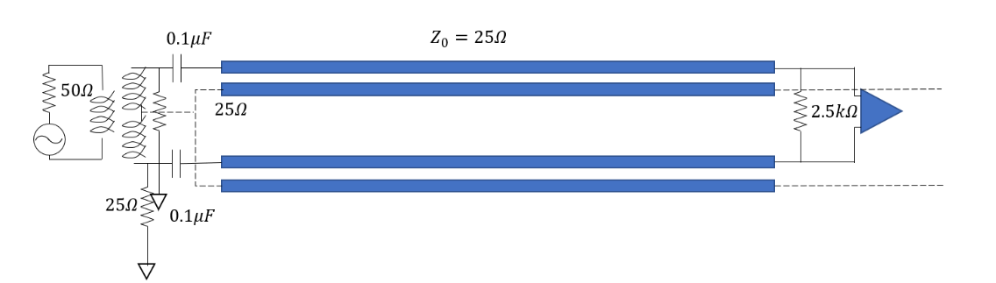

Figure.

Clock signal would be splitted between termination resistor and line trace. In addition reflection coefficient is almost equal to one in end termination. In our experiment, board worked well with 1GHz clock source, however in further design it should be fixed.

## 3.5. Design Improvement